**

CMPE 287 - Software Quality Assurance and Testing

**Fall - 2014**

**Project – Testing Instagram mobile application**



**Instructor:**

Dr. Jerry Gao

**MANUAL TEST REPORT**

**Submission Date: 11/30/2014**

**Submitted by:**

Team - Session1- Group 6

Divanshu Arneja - SJSU ID: 009437064

Piyush Seth - SJSU ID: 009425247

Saumil Jain - SJSU ID: 009428419

Shilpa - SJSU ID: 009392513

Surbhi Rautji - SJSU ID: 009317555

Table of Contents

**1.** **Introduction** 6

1.1. Document Structure 7

1.2. Scope 7

**2.** **Test Case Result & Coverage** 8

2.1. Test case Result – 10

2.1.1. Location based Testing of Photo Map – 10

2.1.1.1. Android Environment – 10

2.1.1.2. IOS Environment – 15

2.1.2. Signup Component– 21

2.1.2.1. Android Environment – 21

2.1.2.2. IOS Environment – 24

2.1.3. Login/Forgot Password Component – 28

2.1.3.1. Android Environment – 28

2.1.3.2. IOS Environment – 30

2.1.4. Home Component – 33

2.1.4.1. Android Environment – 33

2.1.4.2. IOS Environment – 36

2.1.5. Explore Component – 40

2.1.5.1. Android Environment – 40

2.1.5.2. IOS Environment – 42

2.1.6. Camera Component – 45

2.1.6.1. Android Environment – 45

2.1.6.2. IOS Environment – 49

2.1.7. Following/News Component – 53

2.1.7.1. Android Environment – 53

2.1.7.2. IOS Environment – 54

2.1.8. User Profile Component – 55

2.1.8.1. Android Environment – 55

2.1.8.2. IOS Environment – 61

2.1.9. Configuration Testing – 68

2.1.9.1. Android Environment – 68

2.1.9.2. IOS Environment – 70

2.2. Test Case Coverage – 73

2.2.1. Location based Testing of Photo Map – 73

2.2.1.1. Android Environment – 73

2.2.1.2. IOS Environment – 75

2.2.2. Signup Component– 77

2.2.2.1. Android Environment – 77

2.2.2.2. IOS Environment – 78

2.2.3. Login/Forgot Password Component – 79

2.2.3.1. Android Environment – 79

2.2.3.2. IOS Environment – 81

2.2.4. Home Component – 82

2.2.4.1. Android Environment – 82

2.2.4.2. IOS Environment – 83

2.2.5. Explore Component – 85

2.2.5.1. Android Environment – 85

2.2.5.2. IOS Environment – 86

2.2.6. Camera Component – 88

2.2.6.1. Android Environment – 88

2.2.6.2. IOS Environment – 88

2.2.7. Following/News Component – 90

2.2.7.1. Android Environment – 90

2.2.7.2. IOS Environment – 90

2.2.8. User Profile Component – 92

2.2.8.1. Android Environment – 92

2.2.8.2. IOS Environment – 93

2.2.9. Configuration Testing – 95

2.2.9.1. Android Environment – 95

2.2.9.2. IOS Environment – 95

2.2.10. Configuration Distribution Test Result – 97

2.2.11. Test Result Analysis– 98

2.2.12. Test Coverage Report– 99

**3.** **Bug Report Summary –** 100

3.1. Bug Report with Screenshots 100

3.1.1. Bug Report for Signup 100

3.1.1.1. Bug Report for Android 100

3.1.1.2. Bug Report for IOS 105

3.1.2. Bug Report for User Profile 112

3.1.2.1. Bug Report for Android 112

3.1.2.2. Bug Report for IOS 114

3.2. Bug Reporting in Bugzilla 118

3.2.1. Android 118

3.2.2. IOS 119

3.3. Bug Reporting in Elementool – Issue tracker 121

3.4. Features vs Bug Report 123

3.5. Bugs Report with respect to environment and Feature 124

**4.** **Software test cost and complexity -** 125

4.1. Software Test Cost – 125

4.1.1. Infrastructure Cost 125

4.1.2. Tool Cost 125

4.1.3. Human Resource Cost 125

4.2. Software Testing Complexity 126

**5.** **Summary -** 127

**6.** **References** 128

**Version History**

|  |  |  |
| --- | --- | --- |
| **Date** | **Version** | **Description** |
| 11/24/14 | Manual Report 1.0 | Initial Draft. |
| 11/26/14 | Manual Report 1.1 | Inserted more Statistical Reports. |
| 11/28/14 | Manual Report 1.2 | Final Draft. |

## **Introduction**

Instagram is a mobile application which allows the users to take and share photos and videos. Digital filters can be applied to the images. Digital filters can be applied to the images. The application also provides an ability to share photos and videos on a variety of social networking platforms, such as Facebook, Twitter etc. The application also provides location based geo tagging feature.

The features that are being tested are-

1. Signup Component
2. Login/Forgot Password Component
3. Home Component
4. Explore Component
5. Camera Component
6. Following/News Component
7. User Profile Component
8. Location based Testing of Photo Map

The above are the main features that will be tested and the main focus of the testing is to make sure that all the features works as per the functionality. The testing process will require that the inputs and the outputs match the expected output. We will also test the GUI functionality of the application like tap, swipe, double tab etc. For testing the application we have used Equivalence Partitioning method and Decision table method. We have also used Semantic Tree model to test configurations, environment, platform and connectivity testing on the application.

Entire application has been tested for GUI coverage, Environment Coverage, Configuration coverage, Platform coverage and Connectivity coverage.

The test cases have been documented and represented in forms of tables, charts and diagrams.



## Document Structure

Our document structure comprises of the following:

1. Testing Method: This section covers the test methods and coverage criteria.
2. Test Results: This section covers test results, work distribution and coverage report. This is done by using **Elementool**.
3. Bugs: Reporting of bugs and process to replicate it. Bug reporting is done in **Bugzilla** and **Issue tracker in Elementool**.
4. Cost: Cost of testing.
5. Summary: Summary of all the test cases/results using charts and graphs.

## Scope

The scope of the document is to cover all the test cases for all the different components of Instagram. It also provides different testing results. It also gives out all the details information regarding the bugs found during the testing process.

## **Test Case Result & Coverage**

We are using Elementool for documenting the test cases and generating the test case report.

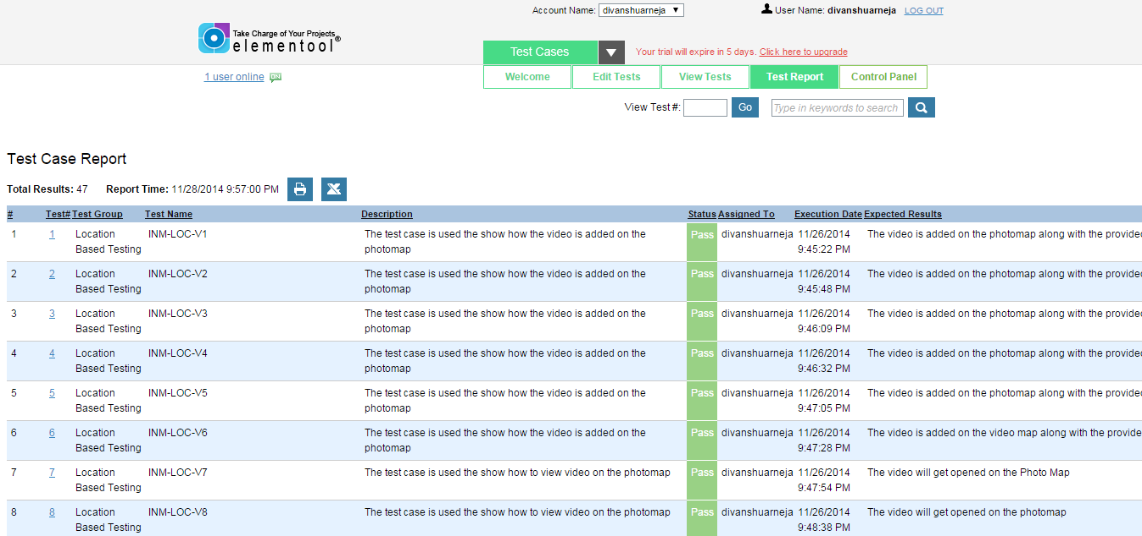

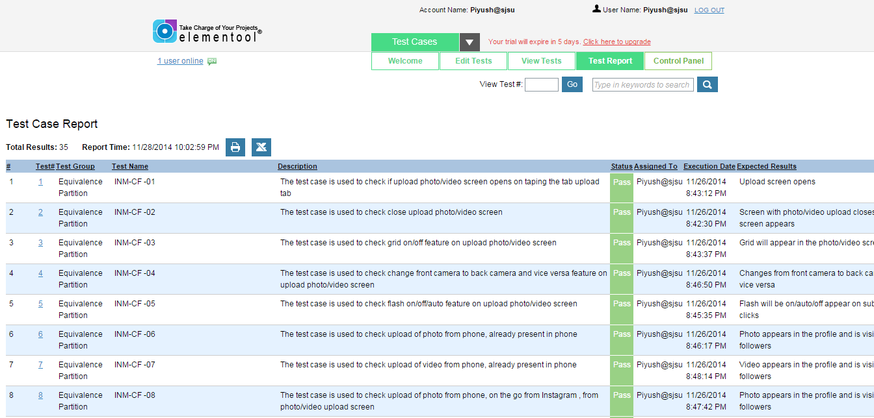

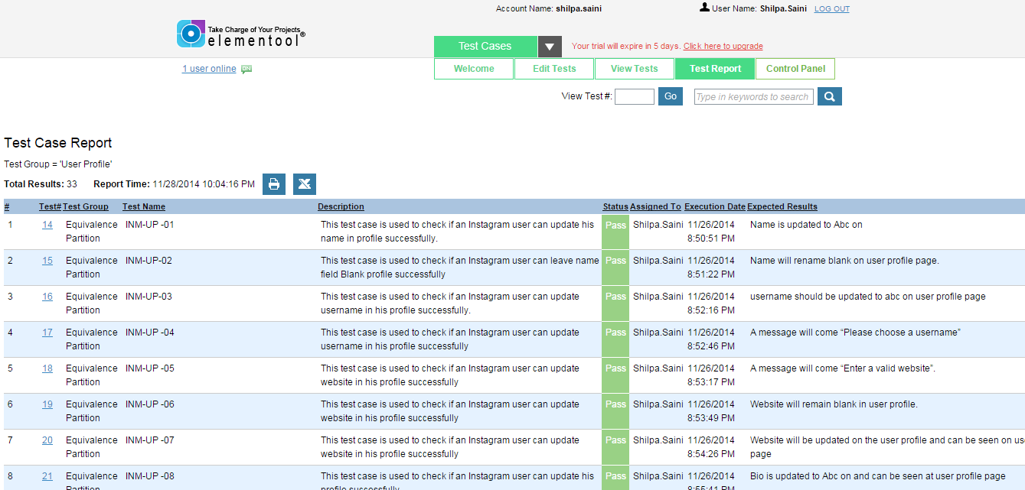

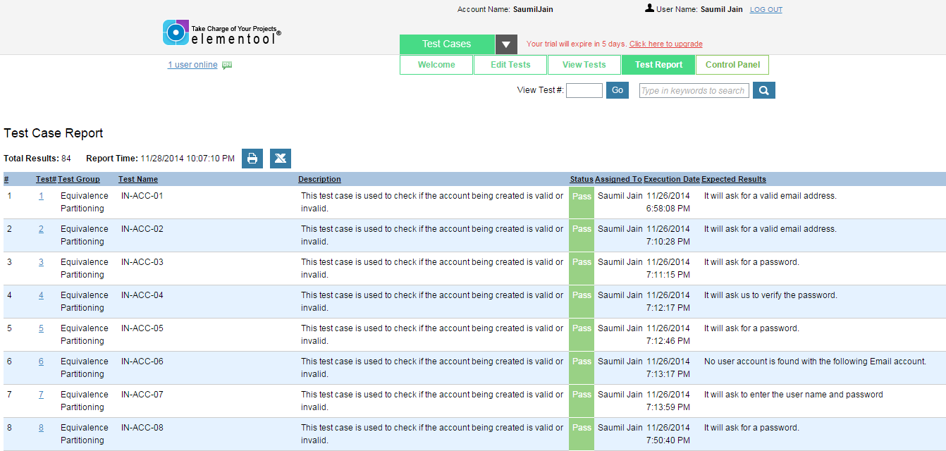

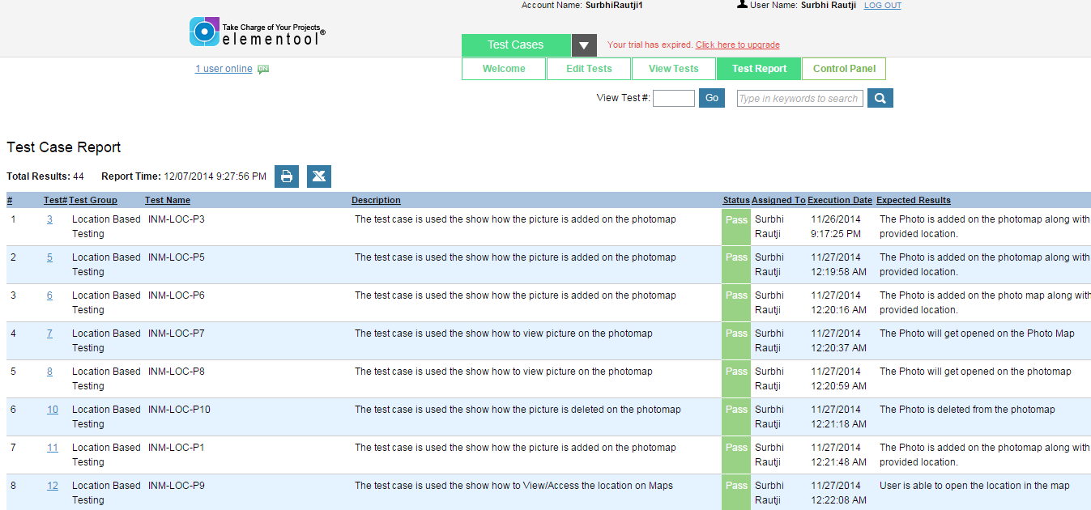

## Test case Result –

## Location based Testing of Photo Map –

**Black box testing -**

* **Decision Table**

## Android Environment –

**Decision Table**

**Application name - Instagram**

**Application Version Number – 6.1.4**

**Testing for Photo –**

|  |  |  |  |  |  |
| --- | --- | --- | --- | --- | --- |
| **Test Case ID** | **Description** | **Status** | **Tester Name** | **Date** | **Expected Results** |
| INM-LOC-P1 | The test case is used the show how the picture is added on the photomap | Pass | Surbhi Rautji | 11/26/2014 | The Photo is added on the photomap along with the provided location. |
| INM-LOC-P2 | The test case is used the show how the picture is added on the photomap | Pass | Surbhi Rautji | 11/26/2014 | The Photo is added on the photomap along with the provided location. |
| INM-LOC-P3 | The test case is used the show how the picture is added on the photomap | Pass | Surbhi Rautji | 11/26/2014 | The Photo is added on the photomap along with the provided location. |
| INM-LOC-P4 | The test case is used the show how the picture is added on the photomap | Pass | Surbhi Rautji | 11/26/2014 | The Photo is added on the photomap along with the provided location. |
| INM-LOC-P5 | The test case is used the show how the picture is added on the photomap | Pass | Surbhi Rautji | 11/26/2014 | The Photo is added on the photomap along with the provided location. |
| INM-LOC-P6 | The test case is used the show how the picture is added on the photomap | Pass | Surbhi Rautji | 11/26/2014 | The Photo is added on the photo map along with the provided location. |
| INM-LOC-P7 | The test case is used the show how to view picture on the photomap | Pass | Surbhi Rautji | 11/26/2014 | The Photo will get opened on the Photo Map |
| INM-LOC-P8 | The test case is used the show how to view picture on the photomap | Pass | Surbhi Rautji | 11/26/2014 | The Photo will get opened on the photomap |
| INM-LOC-P9 | The test case is used the show how to View/Access the location on Maps | Pass | Surbhi Rautji | 11/26/2014 | User is able to open the location in the map |
| INM-LOC-P10 | The test case is used the show how the picture is deleted on the photomap | Pass | Shilpa | 11/26/2014 | The Photo is deleted from the photomap |
| INM-LOC-P11 | The test case is used the show how to create a new location while adding the picture on the photomap | Pass | Shilpa | 11/26/2014 | The photo will get added on the photomap along with the provided location |
| INM-LOC-P12 | The test case is used the show how to View more Picture based on the location selected (Grid view). | Pass | Shilpa | 11/26/2014 | User should be able to view the photos of that location in a grid view |
| INM-LOC-P13 | The test case is used the show how to View more Picture based on the location selected (Timeline view). | Pass | Shilpa | 11/26/2014 | User should be able to view the photos of that location in a Timeline view |
| INM-LOC-P14 | This test case is used to check the stack of pictures viewed on map of Instagram. | Pass | Shilpa | 11/26/2014 | Both the pictures of user will be viewed as a stack on map |
| INM-LOC-P15 | This test case is used to check the stack of pictures viewed on map of Instagram. | Pass | Shilpa | 11/26/2014 | All the pictures of user will be viewed as a stack on map. |
| INM-LOC-P16 | This test case is used to check the stack of pictures viewed on map of Instagram. | Pass | Shilpa | 11/26/2014 | All the pictures of user will be viewed as a stack on map. |
| INM-LOC-P17 | This test case is used to check the zoom in and auto mapping feature of Instagram. | Pass | Shilpa | 11/26/2014 | The map will zoom in and auto-map the photos to location where it is tagged. The Geo objects will also change as map is zoomed in. |
| INM-LOC-P18 | This test case is used to check the zoom in and auto mapping feature of Instagram. | Pass | Shilpa | 11/26/2014 | The map will zoom in and auto-map the photos to location where it is tagged. The Geo objects will also change as map is zoomed in. |
| INM-LOC-P19 | This test case is used to check zoom out feature of Instagram. | Pass | Shilpa | 11/26/2014 | The map will zoom out and photos of nearby locations will be stacked together. The Geo Objects will also change as map is zoomed out. |
| INM-LOC-P20 | This test case is used to check zoom out feature of Instagram. | Pass | Shilpa | 11/26/2014 | The map will zoom out and photos of nearby locations will be stacked together. The Geo Objects will also change as map is zoomed out. |
| INM-LOC-P21 | This test case is used to check that user can edit the location of picture in photo map. | Pass | Shilpa | 11/26/2014 | The photo will be shown in photomap at new location chosen by the User. |
| INM-LOC-P22 | This test case is used to check that user can edit the location of the picture in the photomap. | Pass | Shilpa | 11/26/2014 | The selected photo will be removed from photo map. |

**Testing for Video -**

|  |  |  |  |  |  |
| --- | --- | --- | --- | --- | --- |
| **Test Case ID** | **Description** | **Status** | **Tester Name** | **Date** | **Expected Results** |
| INM-LOC-V1 | The test case is used the show how the video is added on the photomap | Pass | Divanshu Arneja | 11/26/2014 | The video is added on the photomap along with the provided location. |
| INM-LOC-V2 | The test case is used the show how the video is added on the photomap | Pass | Divanshu Arneja | 11/26/2014 | The video is added on the photomap along with the provided location. |
| INM-LOC-V3 | The test case is used the show how the video is added on the photomap | Pass | Divanshu Arneja | 11/26/2014 | The video is added on the photomap along with the provided location. |
| INM-LOC-V4 | The test case is used the show how the video is added on the photomap | Pass | Divanshu Arneja | 11/26/2014 | The video is added on the photomap along with the provided location. |
| INM-LOC-V5 | The test case is used the show how the video is added on the photomap | Pass | Divanshu Arneja | 11/26/2014 | The video is added on the photomap along with the provided location. |
| INM-LOC-V6 | The test case is used the show how the video is added on the photomap | Pass | Divanshu Arneja | 11/26/2014 | The video is added on the video map along with the provided location. |
| INM-LOC-V7 | The test case is used the show how to view video on the photomap | Pass | Divanshu Arneja | 11/26/2014 | The video will get opened on the Photo Map |
| INM-LOC-V8 | The test case is used the show how to view video on the photomap | Pass | Divanshu Arneja | 11/26/2014 | The video will get opened on the photomap |
| INM-LOC-V9 | The test case is used the show how to View/Access the location on Maps | Pass | Divanshu Arneja | 11/26/2014 | User is able to open the location in the map |
| INM-LOC-V10 | The test case is used the show how the video is deleted on the photomap | Pass | Divanshu Arneja | 11/26/2014 | The video is deleted from the photomap |
| INM-LOC-V11 | The test case is used the show how to create a new location while adding the video on the photomap | Pass | Divanshu Arneja | 11/26/2014 | The video will get added on the photomap along with the provided location |
| INM-LOC-V12 | The test case is used the show how to View more Picture based on the location selected (Grid view) | Pass | Divanshu Arneja | 11/26/2014 | User should be able to view the videos of that location in a grid view. |
| INM-LOC-V13 | The test case is used the show how to View more Picture based on the location selected (Timeline view). | Pass | Divanshu Arneja | 11/26/2014 | User should be able to view the videos of that location in a Timeline view. |
| INM-LOC-V14 | This test case is used to check the stack of videos viewed on map of Instagram. | Pass | Divanshu Arneja | 11/26/2014 | Both the videos of user will be viewed as a stack on map. |
| INM-LOC-V15 | This test case is used to check the stack of videos viewed on map of Instagram. | Pass | Divanshu Arneja | 11/26/2014 | All the videos of user will be viewed as a stack on map. |
| INM-LOC-V16 | This test case is used to check the stack of videos viewed on map of Instagram. | Pass | Divanshu Arneja | 11/26/2014 | All the videos of user will be viewed as a stack on map. |
| INM-LOC-V17 | This test case is used to check the zoom in and auto mapping feature of Instagram. | Pass | Divanshu Arneja | 11/26/2014 | The map will zoom in and auto-map the videos to location where it is tagged. The Geo objects will also change as map is zoomed in. |
| INM-LOC-V18 | This test case is used to check the zoom in and auto mapping feature of Instagram. | Pass | Divanshu Arneja | 11/26/2014 | The map will zoom in and auto-map the videos to location where it is tagged. The Geo objects will also change as map is zoomed in. |
| INM-LOC-V19 | This test case is used to check zoom out feature of Instagram. | Pass | Divanshu Arneja | 11/26/2014 | The map will zoom out and videos of nearby locations will be stacked together. The Geo Objects will also change as map is zoomed out. |
| INM-LOC-V20 | This test case is used to check zoom out feature of Instagram. | Pass | Divanshu Arneja | 11/26/2014 | The map will zoom out and videos of nearby locations will be stacked together. The Geo Objects will also change as map is zoomed out. |
| INM-LOC-P21 | This test case is used to check zoom out feature of Instagram. | Pass | Divanshu Arneja | 11/26/2014 | The video will be shown in photomap at new location chosen by the User. |
| INM-LOC-V22 | This test case is used to check zoom out feature of Instagram. | Pass | Divanshu Arneja | 11/26/2014 | The selected video will be removed from photo map. |

## IOS Environment –

**Decision Table**

**Application name - Instagram**

**Application Version Number – 6.1.4**

**Testing for Photo –**

|  |  |  |  |  |  |
| --- | --- | --- | --- | --- | --- |
| **Test Case ID** | **Description** | **Status** | **Tester Name** | **Date** | **Expected Results** |
| INM-LOC-P1 | The test case is used the show how the picture is added on the photomap | Pass | Surbhi Rautji | 11/26/2014 | The Photo is added on the photomap along with the provided location. |
| INM-LOC-P2 | The test case is used the show how the picture is added on the photomap | Pass | Surbhi Rautji | 11/26/2014 | The Photo is added on the photomap along with the provided location. |
| INM-LOC-P3 | The test case is used the show how the picture is added on the photomap | Pass | Surbhi Rautji | 11/26/2014 | The Photo is added on the photomap along with the provided location. |
| INM-LOC-P4 | The test case is used the show how the picture is added on the photomap | Pass | Surbhi Rautji | 11/26/2014 | The Photo is added on the photomap along with the provided location. |
| INM-LOC-P5 | The test case is used the show how the picture is added on the photomap | Pass | Surbhi Rautji | 11/26/2014 | The Photo is added on the photomap along with the provided location. |
| INM-LOC-P6 | The test case is used the show how the picture is added on the photomap | Pass | Surbhi Rautji | 11/26/2014 | The Photo is added on the photo map along with the provided location. |
| INM-LOC-P7 | The test case is used the show how to view picture on the photomap | Pass | Surbhi Rautji | 11/26/2014 | The Photo will get opened on the Photo Map |
| INM-LOC-P8 | The test case is used the show how to view picture on the photomap | Pass | Surbhi Rautji | 11/26/2014 | The Photo will get opened on the photomap |
| INM-LOC-P9 | The test case is used the show how to View/Access the location on Maps | Pass | Surbhi Rautji | 11/26/2014 | User is able to open the location in the map |
| INM-LOC-P10 | The test case is used the show how the picture is deleted on the photomap | Pass | Shilpa | 11/26/2014 | The Photo is deleted from the photomap |
| INM-LOC-P11 | The test case is used the show how to create a new location while adding the picture on the photomap | Pass | Shilpa | 11/26/2014 | The photo will get added on the photomap along with the provided location |
| INM-LOC-P12 | The test case is used the show how to View more Picture based on the location selected (Grid view). | Pass | Shilpa | 11/26/2014 | User should be able to view the photos of that location in a grid view |
| INM-LOC-P13 | The test case is used the show how to View more Picture based on the location selected (Timeline view). | Pass | Shilpa | 11/26/2014 | User should be able to view the photos of that location in a Timeline view |
| INM-LOC-P14 | This test case is used to check the stack of pictures viewed on map of Instagram. | Pass | Shilpa | 11/26/2014 | Both the pictures of user will be viewed as a stack on map |
| INM-LOC-P15 | This test case is used to check the stack of pictures viewed on map of Instagram. | Pass | Shilpa | 11/26/2014 | All the pictures of user will be viewed as a stack on map. |
| INM-LOC-P16 | This test case is used to check the stack of pictures viewed on map of Instagram. | Pass | Shilpa | 11/26/2014 | All the pictures of user will be viewed as a stack on map. |
| INM-LOC-P17 | This test case is used to check the zoom in and auto mapping feature of Instagram. | Pass | Shilpa | 11/26/2014 | The map will zoom in and auto-map the photos to location where it is tagged. The Geo objects will also change as map is zoomed in. |
| INM-LOC-P18 | This test case is used to check the zoom in and auto mapping feature of Instagram. | Pass | Shilpa | 11/26/2014 | The map will zoom in and auto-map the photos to location where it is tagged. The Geo objects will also change as map is zoomed in. |
| INM-LOC-P19 | This test case is used to check zoom out feature of Instagram. | Pass | Shilpa | 11/26/2014 | The map will zoom out and photos of nearby locations will be stacked together. The Geo Objects will also change as map is zoomed out. |
| INM-LOC-P20 | This test case is used to check zoom out feature of Instagram. | Pass | Shilpa | 11/26/2014 | The map will zoom out and photos of nearby locations will be stacked together. The Geo Objects will also change as map is zoomed out. |
| INM-LOC-P21 | This test case is used to check that user can edit the location of picture in photo map. | Pass | Shilpa | 11/26/2014 | The photo will be shown in photomap at new location chosen by the User. |
| INM-LOC-P22 | This test case is used to check that user can edit the location of the picture in the photomap. | Pass | Shilpa | 11/26/2014 | The selected photo will be removed from photo map. |

**Testing for Video -**

|  |  |  |  |  |  |
| --- | --- | --- | --- | --- | --- |
| **Test Case ID** | **Description** | **Status** | **Tester Name** | **Date** | **Expected Results** |
| INM-LOC-V1 | The test case is used the show how the video is added on the photomap | Pass | Divanshu Arneja | 11/26/2014 | The video is added on the photomap along with the provided location. |
| INM-LOC-V2 | The test case is used the show how the video is added on the photomap | Pass | Divanshu Arneja | 11/26/2014 | The video is added on the photomap along with the provided location. |
| INM-LOC-V3 | The test case is used the show how the video is added on the photomap | Pass | Divanshu Arneja | 11/26/2014 | The video is added on the photomap along with the provided location. |
| INM-LOC-V4 | The test case is used the show how the video is added on the photomap | Pass | Divanshu Arneja | 11/26/2014 | The video is added on the photomap along with the provided location. |
| INM-LOC-V5 | The test case is used the show how the video is added on the photomap | Pass | Divanshu Arneja | 11/26/2014 | The video is added on the photomap along with the provided location. |
| INM-LOC-V6 | The test case is used the show how the video is added on the photomap | Pass | Divanshu Arneja | 11/26/2014 | The video is added on the video map along with the provided location. |
| INM-LOC-V7 | The test case is used the show how to view video on the photomap | Pass | Divanshu Arneja | 11/26/2014 | The video will get opened on the Photo Map |
| INM-LOC-V8 | The test case is used the show how to view video on the photomap | Pass | Divanshu Arneja | 11/26/2014 | The video will get opened on the photomap |
| INM-LOC-V9 | The test case is used the show how to View/Access the location on Maps | Pass | Divanshu Arneja | 11/26/2014 | User is able to open the location in the map |
| INM-LOC-V10 | The test case is used the show how the video is deleted on the photomap | Pass | Divanshu Arneja | 11/26/2014 | The video is deleted from the photomap |
| INM-LOC-V11 | The test case is used the show how to create a new location while adding the video on the photomap | Pass | Divanshu Arneja | 11/26/2014 | The video will get added on the photomap along with the provided location |
| INM-LOC-V12 | The test case is used the show how to View more Picture based on the location selected (Grid view) | Pass | Divanshu Arneja | 11/26/2014 | User should be able to view the videos of that location in a grid view. |
| INM-LOC-V13 | The test case is used the show how to View more Picture based on the location selected (Timeline view). | Pass | Divanshu Arneja | 11/26/2014 | User should be able to view the videos of that location in a Timeline view. |
| INM-LOC-V14 | This test case is used to check the stack of videos viewed on map of Instagram. | Pass | Divanshu Arneja | 11/26/2014 | Both the videos of user will be viewed as a stack on map. |
| INM-LOC-V15 | This test case is used to check the stack of videos viewed on map of Instagram. | Pass | Divanshu Arneja | 11/26/2014 | All the videos of user will be viewed as a stack on map. |
| INM-LOC-V16 | This test case is used to check the stack of videos viewed on map of Instagram. | Pass | Divanshu Arneja | 11/26/2014 | All the videos of user will be viewed as a stack on map. |
| INM-LOC-V17 | This test case is used to check the zoom in and auto mapping feature of Instagram. | Pass | Divanshu Arneja | 11/26/2014 | The map will zoom in and auto-map the videos to location where it is tagged. The Geo objects will also change as map is zoomed in. |
| INM-LOC-V18 | This test case is used to check the zoom in and auto mapping feature of Instagram. | Pass | Divanshu Arneja | 11/26/2014 | The map will zoom in and auto-map the videos to location where it is tagged. The Geo objects will also change as map is zoomed in. |
| INM-LOC-V19 | This test case is used to check zoom out feature of Instagram. | Pass | Divanshu Arneja | 11/26/2014 | The map will zoom out and videos of nearby locations will be stacked together. The Geo Objects will also change as map is zoomed out. |
| INM-LOC-V20 | This test case is used to check zoom out feature of Instagram. | Pass | Divanshu Arneja | 11/26/2014 | The map will zoom out and videos of nearby locations will be stacked together. The Geo Objects will also change as map is zoomed out. |
| INM-LOC-P21 | This test case is used to check zoom out feature of Instagram. | Pass | Divanshu Arneja | 11/26/2014 | The video will be shown in photomap at new location chosen by the User. |
| INM-LOC-V22 | This test case is used to check zoom out feature of Instagram. | Pass | Divanshu Arneja | 11/26/2014 | The selected video will be removed from photo map. |

## Signup Component–

**Black box testing -**

* **Equivalence Partition**
* **Decision Table**

## Android Environment –

**Equivalence Partitioning**

**Application name - Instagram**

**Application Version Number – 6.1.4**

|  |  |  |  |  |  |
| --- | --- | --- | --- | --- | --- |
| **Test Case ID** | **Description** | **Status** | **Tester Name** | **Date** | **Expected Results** |
| IN-ACC-01 | This test case is used to check if the account being created is valid or invalid. | Pass | Saumil Jain | 11/26/2014 | It will ask for a valid email address. |
| IN-ACC-02 | This test case is used to check if the account being created is valid or invalid. | Pass | Saumil Jain | 11/26/2014 | It will ask for a valid email address. |
| IN-ACC-03 | This test case is used to check if the account being created is valid or invalid. | Pass | Saumil Jain | 11/26/2014 | It will ask for a password. |
| IN-ACC-04 | This test case is used to check if the account being created is valid or invalid. | Pass | Saumil Jain | 11/26/2014 | It will ask us to verify the password. |
| IN-ACC-05 | This test case is used to check if the account being created is valid or invalid. | Pass | Saumil Jain | 11/26/2014 | It will ask for a password. |
| IN-ACC-06 | This test case is used to check if the account being created is valid or invalid. | Pass | Saumil Jain | 11/26/2014 | No user account is found with the following Email account. |
| IN-ACC-07 | This test case is used to check if the account being created is valid or invalid. | Pass | Saumil Jain | 11/26/2014 | It will ask to enter the user name and password |
| IN-ACC-08 | This test case is used to check if the account being created is valid or invalid. | Pass | Saumil Jain | 11/26/2014 | It will ask for a password. |
| IN-ACC-09 | This test case is used to check if the account being created is valid or invalid. | Pass | Saumil Jain | 11/26/2014 | A pop up message will be displayed asking for a Email address. |
| IN-ACC-10 | This test case is used to check if the account being created is valid or invalid. | Pass | Saumil Jain | 11/26/2014 | A pop up message will be displayed asking for the required fields. |
| IN-ACC-11 | This test case is used to check if the account being created is valid or invalid. | Pass | Saumil Jain | 11/26/2014 | A pop up message will be displayed asking for a valid username. |
| IN-ACC-22 | This test case is used to check if the account being created is valid or invalid. | Pass | Saumil Jain | 11/26/2014 | It will take you to the Facebook Login Page. |
| IN-ACC-23 | This test case is used to check if the account being created is valid or invalid. | Pass | Saumil Jain | 11/26/2014 | It will connect all your Facebook to Instagram. |
| IN-ACC-24 | This test case is used to check if the account being created is valid or invalid. | Pass | Saumil Jain | 11/26/2014 | All the email contacts will be used and you will automatically follow the friends. |
| IN-ACC-25 | This test case is used to check if the account being created is valid or invalid. | Pass | Saumil Jain | 11/26/2014 | It will give suggestions to you to which people you can follow. |
| IN-ACC-26 | This test case is used to check if the account being created is valid or invalid. | Pass | Saumil Jain | 11/26/2014 | The button will turn green and you will be able to see the posts from the people you are following. |
| IN-ACC-27 | This test case is used to check if the account being created is valid or invalid. | Pass | Saumil Jain | 11/26/2014 | You will not follow the user any more. |
| IN-ACC-28 | This test case is used to check if the account being created is valid or invalid. | Pass | Saumil Jain | 11/26/2014 | You will be on your Home Screen. |

**Decision Table**

**Application name - Instagram**

**Application Version Number – 6.1.4**

|  |  |  |  |  |  |
| --- | --- | --- | --- | --- | --- |
| **Test Case ID** | **Description** | **Status** | **Tester Name** | **Date** | **Expected Results** |
| IN-ACC-12 | This test case is used to check if the account being created is valid or invalid. | Pass | Saumil Jain | 11/26/2014 | A pop up message will be displayed asking for the required fields. |
| N-ACC-13 | This test case is used to check if the account being created is valid or invalid. | Pass | Saumil Jain | 11/26/2014 | A pop up message will be displayed asking for the required fields. |
| IN-ACC-14 | This test case is used to check if the email id provided by user exists or not. | Fail | Saumil Jain | 11/26/2014 | Email Id should exist to be updated successfully. |
| IN-ACC-15 | This test case is used to check if the account being created is valid or invalid. | Pass | Saumil Jain | 11/26/2014 | A pop up message will be displayed saying enter a valid user name. |
| IN-ACC-16 | This test case is used to check if the account being created is valid or invalid. | Pass | Saumil Jain | 11/26/2014 | A pop up message will be displayed saying enter a valid password. |
| IN-ACC-17 | This test case is used to check if the email id provided by user exists or not. | Fail | Saumil Jain | 11/26/2014 | Email Id should exist to be updated successfully. |
| IN-ACC-18 | This test case is used to check if the account being created is valid or invalid. | Pass | Saumil Jain | 11/26/2014 | A pop up message will be displayed account created successfully. And it will take to a different page asking for complete name and phone number. |
| IN-ACC-19 | This test case is used to check if the account being created is valid or invalid. | Pass | Saumil Jain | 11/26/2014 | A pop up message suggesting that “Account already exists” with the email address. |
| IN-ACC-20 | This test case is used to check if the account being created is valid or invalid. | Pass | Saumil Jain | 11/26/2014 | A pop up message pointing to enter a correct phone number. |
| IN-ACC-21 | This test case is used to check if the account being created is valid or invalid. | Pass | Saumil Jain | 11/26/2014 | Details will be accepted and it will open a new page to connect through friends through Facebook of email contacts. |

## IOS Environment –

**Equivalence Partitioning**

**Application name - Instagram**

**Application Version Number – 6.1.4**

|  |  |  |  |  |  |
| --- | --- | --- | --- | --- | --- |
| **Test Case ID** | **Description** | **Status** | **Tester Name** | **Date** | **Expected Results** |
| IN-ACC-01 | This test case is used to check if the account being created is valid or invalid. | Pass | Saumil Jain | 11/26/2014 | It will ask for a valid email address. |
| IN-ACC-02 | This test case is used to check if the account being created is valid or invalid. | Pass | Saumil Jain | 11/26/2014 | It will ask for a valid email address. |
| IN-ACC-03 | This test case is used to check if the account being created is valid or invalid. | Pass | Saumil Jain | 11/26/2014 | It will ask for a password. |
| IN-ACC-04 | This test case is used to check if the account being created is valid or invalid. | Pass | Saumil Jain | 11/26/2014 | It will ask us to verify the password. |
| IN-ACC-05 | This test case is used to check if the account being created is valid or invalid. | Pass | Saumil Jain | 11/26/2014 | It will ask for a password. |
| IN-ACC-06 | This test case is used to check if the account being created is valid or invalid. | Pass | Saumil Jain | 11/26/2014 | No user account is found with the following Email account. |
| IN-ACC-07 | This test case is used to check if the account being created is valid or invalid. | Pass | Saumil Jain | 11/26/2014 | It will ask to enter the user name and password |
| IN-ACC-08 | This test case is used to check if the account being created is valid or invalid. | Pass | Saumil Jain | 11/26/2014 | It will ask for a password. |
| IN-ACC-09 | This test case is used to check if the account being created is valid or invalid. | Pass | Saumil Jain | 11/26/2014 | A pop up message will be displayed asking for a Email address. |
| IN-ACC-10 | This test case is used to check if the account being created is valid or invalid. | Pass | Saumil Jain | 11/26/2014 | A pop up message will be displayed asking for the required fields. |
| IN-ACC-11 | This test case is used to check if the account being created is valid or invalid. | Pass | Saumil Jain | 11/26/2014 | A pop up message will be displayed asking for a valid username. |
| IN-ACC-22 | This test case is used to check if the account being created is valid or invalid. | Pass | Saumil Jain | 11/26/2014 | It will take you to the Facebook Login Page. |
| IN-ACC-23 | This test case is used to check if the account being created is valid or invalid. | Pass | Saumil Jain | 11/26/2014 | It will connect all your Facebook to Instagram. |
| IN-ACC-24 | This test case is used to check if the account being created is valid or invalid. | Pass | Saumil Jain | 11/26/2014 | All the email contacts will be used and you will automatically follow the friends. |
| IN-ACC-25 | This test case is used to check if the account being created is valid or invalid. | Pass | Saumil Jain | 11/26/2014 | It will give suggestions to you to which people you can follow. |
| IN-ACC-26 | This test case is used to check if the account being created is valid or invalid. | Pass | Saumil Jain | 11/26/2014 | The button will turn green and you will be able to see the posts from the people you are following. |
| IN-ACC-27 | This test case is used to check if the account being created is valid or invalid. | Pass | Saumil Jain | 11/26/2014 | You will not follow the user any more. |
| IN-ACC-28 | This test case is used to check if the account being created is valid or invalid. | Pass | Saumil Jain | 11/26/2014 | You will be on your Home Screen. |

**Decision Table**

**Application name - Instagram**

**Application Version Number – 6.1.4**

|  |  |  |  |  |  |
| --- | --- | --- | --- | --- | --- |
| **Test Case ID** | **Description** | **Status** | **Tester Name** | **Date** | **Expected Results** |
| IN-ACC-12 | This test case is used to check if the account being created is valid or invalid. | Pass | Saumil Jain | 11/26/2014 | A pop up message will be displayed asking for the required fields. |
| N-ACC-13 | This test case is used to check if the account being created is valid or invalid. | Pass | Saumil Jain | 11/26/2014 | A pop up message will be displayed asking for the required fields. |
| IN-ACC-14 | This test case is used to check if the email id provided by user exists or not. | Fail | Saumil Jain | 11/26/2014 | Email Id should exist to be updated successfully. |
| IN-ACC-15 | This test case is used to check if the account being created is valid or invalid. | Pass | Saumil Jain | 11/26/2014 | A pop up message will be displayed saying enter a valid user name. |
| IN-ACC-16 | This test case is used to check if the account being created is valid or invalid. | Pass | Saumil Jain | 11/26/2014 | A pop up message will be displayed saying enter a valid password. |
| IN-ACC-17 | This test case is used to check if the email id provided by user exists or not. | Fail | Saumil Jain | 11/26/2014 | Email Id should exist to be updated successfully. |
| IN-ACC-18 | This test case is used to check if the account being created is valid or invalid. | Pass | Saumil Jain | 11/26/2014 | A pop up message will be displayed account created successfully. And it will take to a different page asking for complete name and phone number. |
| IN-ACC-19 | This test case is used to check if the account being created is valid or invalid. | Pass | Saumil Jain | 11/26/2014 | A pop up message suggesting that “Account already exists” with the email address. |
| IN-ACC-20 | This test case is used to check if the account being created is valid or invalid. | Pass | Saumil Jain | 11/26/2014 | A pop up message pointing to enter a correct phone number. |
| IN-ACC-21 | This test case is used to check if the account being created is valid or invalid. | Pass | Saumil Jain | 11/26/2014 | Details will be accepted and it will open a new page to connect through friends through Facebook of email contacts. |

## Login/Forgot Password Component –

**Black box testing -**

* **Equivalence Partition**
* **Decision Table**

## Android Environment –

**Equivalence Partitioning**

**Application name - Instagram**

**Application Version Number – 6.1.4**

|  |  |  |  |  |  |
| --- | --- | --- | --- | --- | --- |
| **Test Case ID** | **Description** | **Status** | **Tester Name** | **Date** | **Expected Results** |
| IN-LOG-01 | This test case is used to check if an existing user can login successfully. | Pass | Saumil Jain | 11/26/2014 | A message will pop up asking for the user name. |
| IN-LOG-02 | This test case is used to check if an existing user can login successfully | Pass | Saumil Jain | 11/26/2014 | A message will pop up asking for the password |
| IN-UP-01 | This test case is used to check the Forgot Password option. | Pass | Saumil Jain | 11/26/2014 | A message will pop up asking valid credentials |
| IN-UP-02 | This test case is used to check the Forgot Password option. | Pass | Saumil Jain | 11/26/2014 | Nothing will happen. |
| IN-UP-03 | This test case is used to check the Forgot Password option. | Pass | Saumil Jain | 11/26/2014 | New page opens providing option to reset password through: Send a Password Reset Email. Send a Password Reset SMS. Reset using Facebook. |
| IN-UP-04 | This test case is used to check the Forgot Password option. | Pass | Saumil Jain | 11/26/2014 | A message will pop up saying a password reset link has been send. |
| IN-UP-05 | This test case is used to check the Forgot Password option. | Pass | Saumil Jain | 11/26/2014 | A new page will open asking for the new Password. |
| IN-UP-06 | This test case is used to check the Forgot Password option | Pass | Saumil Jain | 11/26/2014 | User should have a valid user name or Email address. |
| IN-UP-07 | This test case is used to check the Forgot Password option. | Pass | Saumil Jain | 11/26/2014 | A message will pop up saying the password should be atleast 6 digit. |
| IN-UP-08 | This test case is used to check the Forgot Password option. | Pass | Saumil Jain | 11/26/2014 | A message will pop up saying both the passwords should match. |
| IN-UP-09 | This test case is used to check the Forgot Password option. | Pass | Saumil Jain | 11/26/2014 | A message will pop up saying "Congratulations, your password has been reset". |
| IN-UP-10 | This test case is used to check the Forgot Password option. | Pass | Saumil Jain | 11/26/2014 | SMS will be sent with the password reset code. |
| IN-UP-11 | This test case is used to check the Forgot Password option. | Pass | Saumil Jain | 11/26/2014 | A new page asking for a new password and confirm password page will open. |

**Decision Table**

**Application name - Instagram**

**Application Version Number – 6.1.4**

|  |  |  |  |  |  |
| --- | --- | --- | --- | --- | --- |
| **Test Case ID** | **Description** | **Status** | **Tester Name** | **Date** | **Expected Results** |
| IN-LOG-03 | This test case is used to check if an existing user can login successfully. | Pass | Saumil Jain | 11/26/2014 | A message will pop up asking for the password. |
| IN-LOG-04 | This test case is used to check if an existing user can login successfully. | Pass | Saumil Jain | 11/26/2014 | A message will pop up asking valid username/password. |
| IN-LOG-05 | This test case is used to check if an existing user can login successfully. | Pass | Saumil Jain | 11/26/2014 | A message will pop up asking for the password. |
| IN-LOG-06 | This test case is used to check if an existing user can login successfully. | Pass | Saumil Jain | 11/26/2014 | A message will pop up asking for valid password. |
| IN-LOG-07 | This test case is used to check if an existing user can login successfully. | Pass | Saumil Jain | 11/26/2014 | The HOME screen of the account will appear and the user can access the Instagram application |
| IN-UP-12 | This test case is used to check the Forgot Password option. | Pass | Saumil Jain | 11/26/2014 | It will pop up a message asking to put a password in confirm password field. |
| IN-UP-13 | This test case is used to check the Forgot Password option. | Pass | Saumil Jain | 11/26/2014 | A new page asking for a new password and confirm password page will open |
| IN-UP-14 | This test case is used to check the Forgot Password option. | Pass | Saumil Jain | 11/26/2014 | A message will pop up saying "Congratulations, your password has been reset". |
| IN-UP-15 | This test case is used to check the Forgot Password option. | Pass | Saumil Jain | 11/26/2014 | A new page will open asking for the new password. |
| IN-UP-16 | This test case is used to check the Forgot Password option. | Pass | Saumil Jain | 11/26/2014 | A message will pop up saying "Congratulations, your password has been reset". |
| IN-UP-17 | This test case is used to check the Forgot Password option. | Pass | Saumil Jain | 11/26/2014 | A new page asking for a new password and confirm password page will open. |

## IOS Environment –

**Equivalence Partitioning**

**Application name - Instagram**

**Application Version Number – 6.1.4**

|  |  |  |  |  |  |
| --- | --- | --- | --- | --- | --- |
| **Test Case ID** | **Description** | **Status** | **Tester Name** | **Date** | **Expected Results** |
| IN-LOG-01 | This test case is used to check if an existing user can login successfully. | Pass | Saumil Jain | 11/26/2014 | A message will pop up asking for the user name. |
| IN-LOG-02 | This test case is used to check if an existing user can login successfully | Pass | Saumil Jain | 11/26/2014 | A message will pop up asking for the password |
| IN-UP-01 | This test case is used to check the Forgot Password option. | Pass | Saumil Jain | 11/26/2014 | A message will pop up asking valid credentials |
| IN-UP-02 | This test case is used to check the Forgot Password option. | Pass | Saumil Jain | 11/26/2014 | Nothing will happen. |
| IN-UP-03 | This test case is used to check the Forgot Password option. | Pass | Saumil Jain | 11/26/2014 | New page opens providing option to reset password through: Send a Password Reset Email. Send a Password Reset SMS. Reset using Facebook. |
| IN-UP-04 | This test case is used to check the Forgot Password option. | Pass | Saumil Jain | 11/26/2014 | A message will pop up saying a password reset link has been send. |
| IN-UP-05 | This test case is used to check the Forgot Password option. | Pass | Saumil Jain | 11/26/2014 | A new page will open asking for the new Password. |
| IN-UP-06 | This test case is used to check the Forgot Password option | Pass | Saumil Jain | 11/26/2014 | User should have a valid user name or Email address. |
| IN-UP-07 | This test case is used to check the Forgot Password option. | Pass | Saumil Jain | 11/26/2014 | A message will pop up saying the password should be atleast 6 digit. |
| IN-UP-08 | This test case is used to check the Forgot Password option. | Pass | Saumil Jain | 11/26/2014 | A message will pop up saying both the passwords should match. |
| IN-UP-09 | This test case is used to check the Forgot Password option. | Pass | Saumil Jain | 11/26/2014 | A message will pop up saying "Congratulations, your password has been reset". |
| IN-UP-10 | This test case is used to check the Forgot Password option. | Pass | Saumil Jain | 11/26/2014 | SMS will be sent with the password reset code. |
| IN-UP-11 | This test case is used to check the Forgot Password option. | Pass | Saumil Jain | 11/26/2014 | A new page asking for a new password and confirm password page will open. |

**Decision Table**

**Application name - Instagram**

**Application Version Number – 6.1.4**

|  |  |  |  |  |  |
| --- | --- | --- | --- | --- | --- |
| **Test Case ID** | **Description** | **Status** | **Tester Name** | **Date** | **Expected Results** |
| IN-LOG-03 | This test case is used to check if an existing user can login successfully. | Pass | Saumil Jain | 11/26/2014 | A message will pop up asking for the password. |
| IN-LOG-04 | This test case is used to check if an existing user can login successfully. | Pass | Saumil Jain | 11/26/2014 | A message will pop up asking valid username/password. |
| IN-LOG-05 | This test case is used to check if an existing user can login successfully. | Pass | Saumil Jain | 11/26/2014 | A message will pop up asking for the password. |
| IN-LOG-06 | This test case is used to check if an existing user can login successfully. | Pass | Saumil Jain | 11/26/2014 | A message will pop up asking for valid password. |
| IN-LOG-07 | This test case is used to check if an existing user can login successfully. | Pass | Saumil Jain | 11/26/2014 | The HOME screen of the account will appear and the user can access the Instagram application |
| IN-UP-12 | This test case is used to check the Forgot Password option. | Pass | Saumil Jain | 11/26/2014 | It will pop up a message asking to put a password in confirm password field. |
| IN-UP-13 | This test case is used to check the Forgot Password option. | Pass | Saumil Jain | 11/26/2014 | A new page asking for a new password and confirm password page will open |
| IN-UP-14 | This test case is used to check the Forgot Password option. | Pass | Saumil Jain | 11/26/2014 | A message will pop up saying "Congratulations, your password has been reset". |
| IN-UP-15 | This test case is used to check the Forgot Password option. | Pass | Saumil Jain | 11/26/2014 | A new page will open asking for the new password. |
| IN-UP-16 | This test case is used to check the Forgot Password option. | Pass | Saumil Jain | 11/26/2014 | A message will pop up saying "Congratulations, your password has been reset". |
| IN-UP-17 | This test case is used to check the Forgot Password option. | Pass | Saumil Jain | 11/26/2014 | A new page asking for a new password and confirm password page will open. |

## Home Component –

**Black box testing -**

* **Equivalence Partition**
* **Decision Table**

## Android Environment –

**Equivalence Partitioning**

**Application name - Instagram**

**Application Version Number – 6.1.4**

|  |  |  |  |  |  |
| --- | --- | --- | --- | --- | --- |
| **Test Case ID** | **Description** | **Status** | **Tester Name** | **Date** | **Expected Results** |
| IN-HOME-01 | The test case is used to check the Home Screen Features. | Pass | Saumil Jain | 11/26/2014 | A screen with recent uploads of photo from other people will appear. |
| IN-HOME-02 | To test the like feature of the application. | Pass | Saumil Jain | 11/26/2014 | The image will be liked by you. |
| IN-HOME-03 | The test case is used to check the Home Screen features. | Pass | Saumil Jain | 11/26/2014 | The photo will be liked. And the Like Button will turn to Liked Button. |
| IN-HOME-04 | This test case is used to check the unlike feature of photo. | Pass | Saumil Jain | 11/26/2014 | The Liked button will be changed to Like button and you can again Like the photo. |
| IN-HOME-05 | To check the comment feature on the home screen. | Pass | Saumil Jain | 11/26/2014 | A comment will be posted on the photo. |
| IN-HOME-06 | To check the comment feature on the home screen. | Pass | Saumil Jain | 11/26/2014 | A comment will not be posted. |
| IN-HOME-17 | The test case is used to check the profile of a friend. | Pass | Saumil Jain | 11/26/2014 | The Profile of a friend in a new window will open. |
| IN-HOME-18 | The test case is used to check the tag option in comment feature. | Pass | Saumil Jain | 11/26/2014 | A person who wrote the comment will be tagged. |
| IN-HOME-19 | Test case is used to check the comment feature.. | Pass | Saumil Jain | 11/26/2014 | You will get the option to report the comment as spam, scam or Inappropriate comment. |
| IN-HOME-20 | The test case is used to check posts of a particular friend. | Pass | Saumil Jain | 11/26/2014 | Recent updates for the user will be visible. |

**Decision Table**

**Application name - Instagram**

**Application Version Number – 6.1.4**

|  |  |  |  |  |  |
| --- | --- | --- | --- | --- | --- |
| **Test Case ID** | **Description** | **Status** | **Tester Name** | **Date** | **Expected Results** |
| IN-HOME-07 | To check the likes button on the home screen. | Pass | Saumil Jain | 11/26/2014 | A screen with open showing all the people who liked the photo. |
| IN-HOME-08 | The test case is used to check the more option on the screen. | Pass | Saumil Jain | 11/26/2014 | A screen will open with the following option. Report Inappropriate, Copy URL and Cancel. |
| IN-HOME-09 | The test case is used to check the report inappropriate feature. | Pass | Saumil Jain | 11/26/2014 | screen with providing the option under the report inappropriate button will open. |
| IN-HOME-10 | The test case is used to check the report inappropriate feature. | Pass | Saumil Jain | 11/26/2014 | This will open a page where you can block people from updating photos on your Home Screen. |
| IN-HOME-11 | The test case is used to check the report inappropriate features. | Pass | Saumil Jain | 11/26/2014 | This action will investigate and block the photo from Instagram. |
| IN-HOME-12 | The test case is used to check the report inappropriate features. | Pass | Saumil Jain | 11/26/2014 | A screen with options like Self harm, Harassment and Drug use will open. |
| IN-HOME-13 | The test case is used to check the report inappropriate features. | Pass | Saumil Jain | 11/26/2014 | A screen with option like Nudity, Graphic violence, Hate Speech or Intellectual property violation opens. |
| IN-HOME-14 | The test case is used to check the more option on the screen. | Pass | Saumil Jain | 11/26/2014 | This action will copy the selected image on your clipboard. |
| IN-HOME-15 | The test case is used to check delete the comment option | Pass | Saumil Jain | 11/26/2014 | Comment will be deleted. |
| IN-HOME-16 | The test case is used to check the delete comment option. | Pass | Saumil Jain | 11/26/2014 | Comment will not be deleted. |
| IN-HOME-21 | The test case is used to check the home screen features. | Pass | Saumil Jain | 11/26/2014 | You will be able to see all the photos that are posted by a friend. |
| IN-HOME-22 | The test case is used to check the followers button. | Pass | Saumil Jain | 11/26/2014 | A Page will open showing all the people following you. |
| IN-HOME-23 | The test case is used to check the follow button. | Pass | Saumil Jain | 11/26/2014 | The button will be changed to Following Green button . |
| IN-HOME-24 | The test case is used to check the following button. | Pass | Saumil Jain | 11/26/2014 | A page will open that shows all the people you are following |
| IN-HOME-25 | The test case is used to check the follow button. | Pass | Saumil Jain | 11/26/2014 | A Dialog box will open asking you to "Unfollow" or "Cancel". |
| IN-HOME-26 | The test case is used to check the follow button. | Pass | Saumil Jain | 11/26/2014 | The Green Following button will be turned to white Follow button and you will unfollow your friend. |
| IN-HOME-27 | The test case is used to check the follow button. | Pass | Saumil Jain | 11/26/2014 | Clicking on the CANCEL button will close the dialog box. |
| IN-HOME-28 | The test case is used to check the people tag in the photo | Pass | Saumil Jain | 11/26/2014 | It will show the people who are tagged in the photo. |
| IN-HOME-29 | Test case is used check the options on a friend's profile. | Pass | Saumil Jain | 11/26/2014 | It shows all the photos that are being posted by the friend on Instagram. |
| IN-HOME-30 | Test case is used check the options on a friend's profile .. | Pass | Saumil Jain | 11/26/2014 | Clicking that button will show the images on a timeline. |
| IN-HOME-31 | The test case is used to check the geotag feature. | Pass | Saumil Jain | 11/26/2014 | A page will open which shows all the location from where the pictures are posted. |
| IN-HOME-32 | Test case is used to check the photo map button on profile. | Pass | Saumil Jain | 11/26/2014 | A page will open showing all the photos of you other people have uploaded on Instagram. |

## IOS Environment –

**Equivalence Partitioning**

**Application name - Instagram**

**Application Version Number – 6.1.4**

|  |  |  |  |  |  |
| --- | --- | --- | --- | --- | --- |
| **Test Case ID** | **Description** | **Status** | **Tester Name** | **Date** | **Expected Results** |
| IN-HOME-01 | The test case is used to check the Home Screen Features. | Pass | Saumil Jain | 11/26/2014 | A screen with recent uploads of photo from other people will appear. |
| IN-HOME-02 | To test the like feature of the application. | Pass | Saumil Jain | 11/26/2014 | The image will be liked by you. |
| IN-HOME-03 | The test case is used to check the Home Screen features. | Pass | Saumil Jain | 11/26/2014 | The photo will be liked. And the Like Button will turn to Liked Button. |
| IN-HOME-04 | This test case is used to check the unlike feature of photo. | Pass | Saumil Jain | 11/26/2014 | The Liked button will be changed to Like button and you can again Like the photo. |
| IN-HOME-05 | To check the comment feature on the home screen. | Pass | Saumil Jain | 11/26/2014 | A comment will be posted on the photo. |
| IN-HOME-06 | To check the comment feature on the home screen. | Pass | Saumil Jain | 11/26/2014 | A comment will not be posted. |
| IN-HOME-17 | The test case is used to check the profile of a friend. | Pass | Saumil Jain | 11/26/2014 | The Profile of a friend in a new window will open. |
| IN-HOME-18 | The test case is used to check the tag option in comment feature. | Pass | Saumil Jain | 11/26/2014 | A person who wrote the comment will be tagged. |
| IN-HOME-19 | Test case is used to check the comment feature. | Pass | Saumil Jain | 11/26/2014 | You will get the option to report the comment as spam, scam or Inappropriate comment. |
| IN-HOME-20 | The test case is used to check posts of a particular friend. | Pass | Saumil Jain | 11/26/2014 | Recent updates for the user will be visible. |

**Decision Table**

**Application name - Instagram**

**Application Version Number – 6.1.4**

|  |  |  |  |  |  |
| --- | --- | --- | --- | --- | --- |
| **Test Case ID** | **Description** | **Status** | **Tester Name** | **Date** | **Expected Results** |
| IN-HOME-07 | To check the likes button on the home screen. | Pass | Saumil Jain | 11/26/2014 | A screen with open showing all the people who liked the photo. |
| IN-HOME-08 | The test case is used to check the more option on the screen. | Pass | Saumil Jain | 11/26/2014 | A screen will open with the following option. Report Inappropriate, Copy URL and Cancel. |
| IN-HOME-09 | The test case is used to check the report inappropriate feature. | Pass | Saumil Jain | 11/26/2014 | screen with providing the option under the report inappropriate button will open. |
| IN-HOME-10 | The test case is used to check the report inappropriate feature. | Pass | Saumil Jain | 11/26/2014 | This will open a page where you can block people from updating photos on your Home Screen. |
| IN-HOME-11 | The test case is used to check the report inappropriate features. | Pass | Saumil Jain | 11/26/2014 | This action will investigate and block the photo from Instagram. |
| IN-HOME-12 | The test case is used to check the report inappropriate features. | Pass | Saumil Jain | 11/26/2014 | A screen with options like Self harm, Harassment and Drug use will open. |
| IN-HOME-13 | The test case is used to check the report inappropriate features. | Pass | Saumil Jain | 11/26/2014 | A screen with option like Nudity, Graphic violence, Hate Speech or Intellectual property violation opens. |
| IN-HOME-14 | The test case is used to check the more option on the screen. | Pass | Saumil Jain | 11/26/2014 | This action will copy the selected image on your clipboard. |
| IN-HOME-15 | The test case is used to check delete the comment option | Pass | Saumil Jain | 11/26/2014 | Comment will be deleted. |
| IN-HOME-16 | The test case is used to check the delete comment option. | Pass | Saumil Jain | 11/26/2014 | Comment will not be deleted. |
| IN-HOME-21 | The test case is used to check the home screen features. | Pass | Saumil Jain | 11/26/2014 | You will be able to see all the photos that are posted by a friend. |
| IN-HOME-22 | The test case is used to check the followers button. | Pass | Saumil Jain | 11/26/2014 | A Page will open showing all the people following you. |
| IN-HOME-23 | The test case is used to check the follow button. | Pass | Saumil Jain | 11/26/2014 | The button will be changed to Following Green button . |
| IN-HOME-24 | The test case is used to check the following button. | Pass | Saumil Jain | 11/26/2014 | A page will open that shows all the people you are following |
| IN-HOME-25 | The test case is used to check the follow button. | Pass | Saumil Jain | 11/26/2014 | A Dialog box will open asking you to "Unfollow" or "Cancel". |
| IN-HOME-26 | The test case is used to check the follow button. | Pass | Saumil Jain | 11/26/2014 | The Green Following button will be turned to white Follow button and you will unfollow your friend. |
| IN-HOME-27 | The test case is used to check the follow button. | Pass | Saumil Jain | 11/26/2014 | Clicking on the CANCEL button will close the dialog box. |
| IN-HOME-28 | The test case is used to check the people tag in the photo | Pass | Saumil Jain | 11/26/2014 | It will show the people who are tagged in the photo. |
| IN-HOME-29 | Test case is used check the options on a friend's profile. | Pass | Saumil Jain | 11/26/2014 | It shows all the photos that are being posted by the friend on Instagram. |
| IN-HOME-30 | Test case is used check the options on a friend's profile .. | Pass | Saumil Jain | 11/26/2014 | Clicking that button will show the images on a timeline. |
| IN-HOME-31 | The test case is used to check the geotag feature. | Pass | Saumil Jain | 11/26/2014 | A page will open which shows all the location from where the pictures are posted. |
| IN-HOME-32 | Test case is used to check the photo map button on profile. | Pass | Saumil Jain | 11/26/2014 | A page will open showing all the photos of you other people have uploaded on Instagram. |

## Explore Component –

**Black box testing -**

* **Equivalence Partition**
* **Decision Table**

## Android Environment –

**Equivalence Partitioning**

**Application name - Instagram**

**Application Version Number – 6.1.4**

|  |  |  |  |  |  |
| --- | --- | --- | --- | --- | --- |
| **Test Case ID** | **Description** | **Status** | **Tester Name** | **Date** | **Expected Results** |
| INM-EXPLR -05 | This test case is used to check if an Instagram user can comment on the photo. | Pass | Divanshu Arneja | 11/26/2014 | User should be able to comment on the photo |
| INM-EXPLR -10 | Description: This test case is used to check if an Instagram user can search under explore. | Pass | Divanshu Arneja | 11/26/2014 | Nothings gets searched |
| INM-EXPLR -11 | This test case is used to check if an Instagram user can search under explore. | Pass | Divanshu Arneja | 11/26/2014 | Expected Output: Search shows the result (users or hashtags) if present |
| INM-EXPLR -12 | This test case is used to check if an Instagram user can search under explore. | Pass | Divanshu Arneja | 11/26/2014 | Search shows the result (users or hashtags) if present |
| INM-EXPLR -13 | Description: This test case is used to check if an Instagram user can search under explore. | Pass | Divanshu Arneja | 11/26/2014 | Search shows the result (users or hashtags) if present. User can navigate to user profile or the photos selected via hashtags |
| INM-EXPLR -14 | This test case is used to check if an Instagram user can search under explore. | Pass | Divanshu Arneja | 11/26/2014 | Search shows the result (users or hashtags) if present. User can navigate to user profile or the photos selected via hashtags |
| INM-EXPLR -15 | This test case is used to check if an Instagram user can search under explore. | Pass | Divanshu Arneja | 11/26/2014 | Search shows the result (users or hashtags) if present. User can navigate to user profile or the photos selected via hashtags |
| INM-EXPLR -16 | This test case is used to check if an Instagram user can search under explore. | Pass | Divanshu Arneja | 11/26/2014 | Search shows the result (users or hashtags) if present. User can navigate to user profile or the photos selected via hashtags |
| INM-EXPLR -17 | This test case is used to check if an Instagram user can search under explore. | Pass | Divanshu Arneja | 11/26/2014 | Search shows the result (users or hashtags) if present. User can navigate to user profile or the photos selected via hashtags |

**Decision Table**

**Application name - Instagram**

**Application Version Number – 6.1.4**

|  |  |  |  |  |  |
| --- | --- | --- | --- | --- | --- |
| **Test Case ID** | **Description** | **Status** | **Tester Name** | **Date** | **Expected Results** |
| INM-EXPLR -01 | This test case is used to check if an Instagram user can use the explore feature. | Pass | Divanshu Arneja | 11/26/2014 | Explore screen should open |
| INM-EXPLR -02 | This test case is used to check if an Instagram user can view the photos on explore feature. | Pass | Divanshu Arneja | 11/26/2014 | User should be able to view the photo, its likes and comments |
| INM-EXPLR -03 | This test case is used to check if an Instagram user can like the photos on explore feature. | Pass | Divanshu Arneja | 11/26/2014 | User should be able to like the photo and the no of likes are increased by 1 |
| INM-EXPLR -04 | This test case is used to check if an Instagram user can unlike the photo that is already liked by user on explore feature. | Pass | Divanshu Arneja | 11/26/2014 | User should be able to unlike the photo which was already liked and the no of likes are decreased by 1 |
| INM-EXPLR -06 | Description: This test case is used to check if an Instagram user can delete comment on the photo. | Pass | Divanshu Arneja | 11/26/2014 | Users comment should be deleted |
| INM-EXPLR -07 | This test case is used to check if an Instagram user can reply to a comment of another user on the photo. | Pass | Divanshu Arneja | 11/26/2014 | Expected Output: Users comment should be able to reply to the comment. |
| INM-EXPLR -08 | This test case is used to check if an Instagram user can report a comment of another user on the photo. | Pass | Divanshu Arneja | 11/26/2014 | Another Users comment should be able to report the comment as spam or inappropriate. |
| INM-EXPLR -09 | Description: This test case is used to check if an Instagram user can report a comment of another user on the photo. | Pass | Divanshu Arneja | 11/26/2014 | Users comment should be able to report the comment as abusive content. |
| INM-EXPLR -18 | This test case is used to check if an Instagram user can search under explore. | Pass | Divanshu Arneja | 11/26/2014 | Search shows the result (users or hashtags) if present. User can navigate to user profile or the photos selected via hashtags |

## IOS Environment –

**Equivalence Partitioning**

**Application name - Instagram**

**Application Version Number – 6.1.4**

|  |  |  |  |  |  |
| --- | --- | --- | --- | --- | --- |
| **Test Case ID** | **Description** | **Status** | **Tester Name** | **Date** | **Expected Results** |
| INM-EXPLR -05 | This test case is used to check if an Instagram user can comment on the photo. | Pass | Divanshu Arneja | 11/26/2014 | User should be able to comment on the photo |
| INM-EXPLR -10 | Description: This test case is used to check if an Instagram user can search under explore. | Pass | Divanshu Arneja | 11/26/2014 | Nothings gets searched |
| INM-EXPLR -11 | This test case is used to check if an Instagram user can search under explore. | Pass | Divanshu Arneja | 11/26/2014 | Expected Output: Search shows the result (users or hashtags) if present |
| INM-EXPLR -12 | This test case is used to check if an Instagram user can search under explore. | Pass | Divanshu Arneja | 11/26/2014 | Search shows the result (users or hashtags) if present |
| INM-EXPLR -13 | Description: This test case is used to check if an Instagram user can search under explore. | Pass | Divanshu Arneja | 11/26/2014 | Search shows the result (users or hashtags) if present. User can navigate to user profile or the photos selected via hashtags |
| INM-EXPLR -14 | This test case is used to check if an Instagram user can search under explore. | Pass | Divanshu Arneja | 11/26/2014 | Search shows the result (users or hashtags) if present. User can navigate to user profile or the photos selected via hashtags |
| INM-EXPLR -15 | This test case is used to check if an Instagram user can search under explore. | Pass | Divanshu Arneja | 11/26/2014 | Search shows the result (users or hashtags) if present. User can navigate to user profile or the photos selected via hashtags |
| INM-EXPLR -16 | This test case is used to check if an Instagram user can search under explore. | Pass | Divanshu Arneja | 11/26/2014 | Search shows the result (users or hashtags) if present. User can navigate to user profile or the photos selected via hashtags |
| INM-EXPLR -17 | This test case is used to check if an Instagram user can search under explore. | Pass | Divanshu Arneja | 11/26/2014 | Search shows the result (users or hashtags) if present. User can navigate to user profile or the photos selected via hashtags |

**Decision Table**

**Application name - Instagram**

**Application Version Number – 6.1.4**

|  |  |  |  |  |  |
| --- | --- | --- | --- | --- | --- |
| **Test Case ID** | **Description** | **Status** | **Tester Name** | **Date** | **Expected Results** |
| INM-EXPLR -01 | This test case is used to check if an Instagram user can use the explore feature. | Pass | Divanshu Arneja | 11/26/2014 | Explore screen should open |
| INM-EXPLR -02 | This test case is used to check if an Instagram user can view the photos on explore feature. | Pass | Divanshu Arneja | 11/26/2014 | User should be able to view the photo, its likes and comments |
| INM-EXPLR -03 | This test case is used to check if an Instagram user can like the photos on explore feature. | Pass | Divanshu Arneja | 11/26/2014 | User should be able to like the photo and the no of likes are increased by 1 |
| INM-EXPLR -04 | This test case is used to check if an Instagram user can unlike the photo that is already liked by user on explore feature. | Pass | Divanshu Arneja | 11/26/2014 | User should be able to unlike the photo which was already liked and the no of likes are decreased by 1 |
| INM-EXPLR -06 | Description: This test case is used to check if an Instagram user can delete comment on the photo. | Pass | Divanshu Arneja | 11/26/2014 | Users comment should be deleted |
| INM-EXPLR -07 | This test case is used to check if an Instagram user can reply to a comment of another user on the photo. | Pass | Divanshu Arneja | 11/26/2014 | Expected Output: Users comment should be able to reply to the comment. |
| INM-EXPLR -08 | This test case is used to check if an Instagram user can report a comment of another user on the photo. | Pass | Divanshu Arneja | 11/26/2014 | Another Users comment should be able to report the comment as spam or inappropriate. |
| INM-EXPLR -09 | Description: This test case is used to check if an Instagram user can report a comment of another user on the photo. | Pass | Divanshu Arneja | 11/26/2014 | Users comment should be able to report the comment as abusive content. |
| INM-EXPLR -18 | This test case is used to check if an Instagram user can search under explore. | Pass | Divanshu Arneja | 11/26/2014 | Search shows the result (users or hashtags) if present. User can navigate to user profile or the photos selected via hashtags |

## Camera Component –

**Black box testing -**

* **Decision Table**

## Android Environment –

**Decision Table**

**Application name - Instagram**

**Application Version Number – 6.1.4**

|  |  |  |  |  |  |
| --- | --- | --- | --- | --- | --- |
| **Test Case ID** | **Description** | **Status** | **Tester Name** | **Date** | **Expected Results** |
| INM-CF -01 | The test case is used to check if upload photo/video screen opens on taping the tab upload tab | Pass | Piyush Seth | 11/26/2014 | Upload screen opens |
| INM-CF -02 | The test case is used to check close upload photo/video screen | Pass | Piyush Seth | 11/26/2014 | Screen with photo/video upload closes and home screen appears |
| INM-CF -03 | The test case is used to check grid on/off feature on upload photo/video screen | Pass | Piyush Seth | 11/26/2014 | Grid will appear in the photo/video screen |
| INM-CF -04 | The test case is used to check change front camera to back camera and vice versa feature on upload photo/video screen | Pass | Piyush Seth | 11/26/2014 | Changes from front camera to back camera and vice versa |
| INM-CF -05 | The test case is used to check flash on/off/auto feature on upload photo/video screen | Pass | Piyush Seth | 11/26/2014 | Flash will be on/auto/off appear on subsequent clicks |
| INM-CF -06 | The test case is used to check upload of photo from phone, already present in phone | Pass | Piyush Seth | 11/26/2014 | Photo appears in the profile and is visible to followers |
| INM-CF -07 | The test case is used to check upload of video from phone, already present in phone | Pass | Piyush Seth | 11/26/2014 | Video appears in the profile and is visible to followers |
| INM-CF -08 | The test case is used to check upload of photo from phone, on the go from Instagram , from photo/video upload screen | Pass | Piyush Seth | 11/26/2014 | Photo appears in the profile and is visible to followers |
| INM-CF -09 | The test case is used to check upload of video from phone, on the go record from Instagram , from photo/video upload screen | Pass | Piyush Seth | 11/26/2014 | Video appears in the profile and is visible to followers |
| INM-CF -10 | The test case is used to check upload of video from phone, already present in phone | Pass | Piyush Seth | 11/26/2014 | Video appears in the profile and is visible to followers |
| INM-CF -11 | The test case is used to apply filter on photo/video | Pass | Piyush Seth | 11/26/2014 | Photo/Video with “Amaro” appears in the profile and is visible to followers |
| INM-CF -12 | The test case is used to apply filter on photo/video | Pass | Piyush Seth | 11/26/2014 | Photo/Video with “Mayfair” appears in the profile and is visible to followers |
| INM-CF -13 | The test case is used to apply filter on photo/video | Pass | Piyush Seth | 11/26/2014 | Photo/Video with “Rise” appears in the profile and is visible to followers |
| INM-CF -14 | The test case is used to apply filter on photo/video | Pass | Piyush Seth | 11/26/2014 | Photo/Video with “Hudson” appears in the profile and is visible to followers |
| INM-CF -15 | The test case is used to apply filter on photo/video | Pass | Piyush Seth | 11/26/2014 | Photo/Video with “Valencia” appears in the profile and is visible to followers |
| INM-CF -16 | The test case is used to apply filter on photo/video | Pass | Piyush Seth | 11/26/2014 | Photo/Video with “X-Pro II” appears in the profile and is visible to followers |
| INM-CF -17 | The test case is used to apply filter on photo/video | Pass | Piyush Seth | 11/26/2014 | Photo/Video with “Sierra” appears in the profile and is visible to followers |
| INM-CF -18 | The test case is used to apply filter on photo/video | Pass | Piyush Seth | 11/26/2014 | Photo/Video with “Willow” appears in the profile and is visible to followers |
| INM-CF -19 | The test case is used to apply filter on photo/video | Pass | Piyush Seth | 11/26/2014 | Photo/Video with “Lo Fi” appears in the profile and is visible to followers |
| INM-CF -20 | The test case is used to apply filter on photo/video | Pass | Piyush Seth | 11/26/2014 | Photo/Video with “Earlybird” appears in the profile and is visible to followers |
| INM-CF -21 | The test case is used to apply filter on photo/video | Pass | Piyush Seth | 11/26/2014 | Photo/Video with “Sutro” appears in the profile and is visible to followers |
| INM-CF -22 | The test case is used to apply filter on photo/video | Pass | Piyush Seth | 11/26/2014 | Photo/Video with “Toaster” appears in the profile and is visible to followers |
| INM-CF -23 | The test case is used to apply filter on photo/video | Pass | Piyush Seth | 11/26/2014 | Photo/Video with “Brannan” appears in the profile and is visible to followers |
| INM-CF -24 | The test case is used to apply filter on photo/video | Pass | Piyush Seth | 11/26/2014 | Photo/Video with “Inkwell” appears in the profile and is visible to followers |
| INM-CF -25 | The test case is used to apply filter on photo/video | Pass | Piyush Seth | 11/26/2014 | Photo/Video with “Walden” appears in the profile and is visible to followers |
| INM-CF -26 | The test case is used to apply filter on photo/video | Pass | Piyush Seth | 11/26/2014 | Photo/Video with “Hefe” appears in the profile and is visible to followers |
| INM-CF -27 | The test case is used to apply filter on photo/video | Pass | Piyush Seth | 11/26/2014 | Photo/Video with “Nashville” appears in the profile and is visible to followers |
| INM-CF -28 | The test case is used to apply filter on photo/video | Pass | Piyush Seth | 11/26/2014 | Photo/Video with “1977” appears in the profile and is visible to followers |
| INM-CF -29 | The test case is used to apply filter on photo/video | Pass | Piyush Seth | 11/26/2014 | Photo/Video with “Kelvin” appears in the profile and is visible to followers |
| INM-CF -30 | The test case is used to increase/decrease LUX on photo/video | Pass | Piyush Seth | 11/26/2014 | Photo/Video with customized LUX appears in the profile and is visible to followers |
| INM-CF -31 | The test case is used to apply image settings like brightness/adjust/contrast/warmth/saturation/highlights/shadows/vignette/tilt shift/sharpen on photo/video | Pass | Piyush Seth | 11/26/2014 | Photo/Video with customized contrast appears in the profile and is visible to followers |
| INM-CF -32 | The test case is used to share to Direct feature on photo/video | Pass | Piyush Seth | 11/26/2014 | Photo/Video with appears in the profile and is visible to people selected while Direct to selection |
| INM-CF -33 | The test case is used check tag people feature on photo/ video upload | Pass | Piyush Seth | 11/26/2014 | Photo/Video with people tagged in it appears in the profile and is visible to followers |
| INM-CF -34 | The test case is used “add to photo map” on photo/ video upload | Pass | Piyush Seth | 11/26/2014 | Photo/Video is added to map and is visible to followers |
| INM-CF -35 | The test case is used “add to photo map” on photo/ video upload | Pass | Piyush Seth | 11/26/2014 | Photo/Video is added to map and is visible to followers |

## IOS Environment –

**Decision Table**

**Application name - Instagram**

**Application Version Number – 6.1.4**

|  |  |  |  |  |  |
| --- | --- | --- | --- | --- | --- |
| **Test Name** | **Description** | **Status** | **Tester Name** | **Date** | **Expected Results** |
| INM-CF -01 | The test case is used to check if upload photo/video screen opens on taping the tab upload tab | Pass | Piyush Seth | 11/26/2014 | Upload screen opens |
| INM-CF -02 | The test case is used to check close upload photo/video screen | Pass | Piyush Seth | 11/26/2014 | Screen with photo/video upload closes and home screen appears |
| INM-CF -03 | The test case is used to check grid on/off feature on upload photo/video screen | Pass | Piyush Seth | 11/26/2014 | Grid will appear in the photo/video screen |
| INM-CF -04 | The test case is used to check change front camera to back camera and vice versa feature on upload photo/video screen | Pass | Piyush Seth | 11/26/2014 | Changes from front camera to back camera and vice versa |
| INM-CF -05 | The test case is used to check flash on/off/auto feature on upload photo/video screen | Pass | Piyush Seth | 11/26/2014 | Flash will be on/auto/off appear on subsequent clicks |
| INM-CF -06 | The test case is used to check upload of photo from phone, already present in phone | Pass | Piyush Seth | 11/26/2014 | Photo appears in the profile and is visible to followers |
| INM-CF -07 | The test case is used to check upload of video from phone, already present in phone | Pass | Piyush Seth | 11/26/2014 | Video appears in the profile and is visible to followers |
| INM-CF -08 | The test case is used to check upload of photo from phone, on the go from Instagram , from photo/video upload screen | Pass | Piyush Seth | 11/26/2014 | Photo appears in the profile and is visible to followers |
| INM-CF -09 | The test case is used to check upload of video from phone, on the go record from Instagram , from photo/video upload screen | Pass | Piyush Seth | 11/26/2014 | Video appears in the profile and is visible to followers |
| INM-CF -10 | The test case is used to check upload of video from phone, already present in phone | Pass | Piyush Seth | 11/26/2014 | Video appears in the profile and is visible to followers |
| INM-CF -11 | The test case is used to apply filter on photo/video | Pass | Piyush Seth | 11/26/2014 | Photo/Video with “Amaro” appears in the profile and is visible to followers |
| INM-CF -12 | The test case is used to apply filter on photo/video | Pass | Piyush Seth | 11/26/2014 | Photo/Video with “Mayfair” appears in the profile and is visible to followers |
| INM-CF -13 | The test case is used to apply filter on photo/video | Pass | Piyush Seth | 11/26/2014 | Photo/Video with “Rise” appears in the profile and is visible to followers |
| INM-CF -14 | The test case is used to apply filter on photo/video | Pass | Piyush Seth | 11/26/2014 | Photo/Video with “Hudson” appears in the profile and is visible to followers |
| INM-CF -15 | The test case is used to apply filter on photo/video | Pass | Piyush Seth | 11/26/2014 | Photo/Video with “Valencia” appears in the profile and is visible to followers |
| INM-CF -16 | The test case is used to apply filter on photo/video | Pass | Piyush Seth | 11/26/2014 | Photo/Video with “X-Pro II” appears in the profile and is visible to followers |
| INM-CF -17 | The test case is used to apply filter on photo/video | Pass | Piyush Seth | 11/26/2014 | Photo/Video with “Sierra” appears in the profile and is visible to followers |
| INM-CF -18 | The test case is used to apply filter on photo/video | Pass | Piyush Seth | 11/26/2014 | Photo/Video with “Willow” appears in the profile and is visible to followers |
| INM-CF -19 | The test case is used to apply filter on photo/video | Pass | Piyush Seth | 11/26/2014 | Photo/Video with “Lo Fi” appears in the profile and is visible to followers |
| INM-CF -20 | The test case is used to apply filter on photo/video | Pass | Piyush Seth | 11/26/2014 | Photo/Video with “Earlybird” appears in the profile and is visible to followers |
| INM-CF -21 | The test case is used to apply filter on photo/video | Pass | Piyush Seth | 11/26/2014 | Photo/Video with “Sutro” appears in the profile and is visible to followers |
| INM-CF -22 | The test case is used to apply filter on photo/video | Pass | Piyush Seth | 11/26/2014 | Photo/Video with “Toaster” appears in the profile and is visible to followers |
| INM-CF -23 | The test case is used to apply filter on photo/video | Pass | Piyush Seth | 11/26/2014 | Photo/Video with “Brannan” appears in the profile and is visible to followers |
| INM-CF -24 | The test case is used to apply filter on photo/video | Pass | Piyush Seth | 11/26/2014 | Photo/Video with “Inkwell” appears in the profile and is visible to followers |
| INM-CF -25 | The test case is used to apply filter on photo/video | Pass | Piyush Seth | 11/26/2014 | Photo/Video with “Walden” appears in the profile and is visible to followers |
| INM-CF -26 | The test case is used to apply filter on photo/video | Pass | Piyush Seth | 11/26/2014 | Photo/Video with “Hefe” appears in the profile and is visible to followers |
| INM-CF -27 | The test case is used to apply filter on photo/video | Pass | Piyush Seth | 11/26/2014 | Photo/Video with “Nashville” appears in the profile and is visible to followers |
| INM-CF -28 | The test case is used to apply filter on photo/video | Pass | Piyush Seth | 11/26/2014 | Photo/Video with “1977” appears in the profile and is visible to followers |
| INM-CF -29 | The test case is used to apply filter on photo/video | Pass | Piyush Seth | 11/26/2014 | Photo/Video with “Kelvin” appears in the profile and is visible to followers |
| INM-CF -30 | The test case is used to increase/decrease LUX on photo/video | Pass | Piyush Seth | 11/26/2014 | Photo/Video with customized LUX appears in the profile and is visible to followers |
| INM-CF -31 | The test case is used to apply image settings like brightness/adjust/contrast/warmth/saturation/highlights/shadows/vignette/tilt shift/sharpen on photo/video | Pass | Piyush Seth | 11/26/2014 | Photo/Video with customized contrast appears in the profile and is visible to followers |
| INM-CF -32 | The test case is used to share to Direct feature on photo/video | Pass | Piyush Seth | 11/26/2014 | Photo/Video with appears in the profile and is visible to people selected while Direct to selection |
| INM-CF -33 | The test case is used check tag people feature on photo/ video upload | Pass | Piyush Seth | 11/26/2014 | Photo/Video with people tagged in it appears in the profile and is visible to followers |
| INM-CF -34 | The test case is used “add to photo map” on photo/ video upload | Pass | Piyush Seth | 11/26/2014 | Photo/Video is added to map and is visible to followers |
| INM-CF -35 | The test case is used “add to photo map” on photo/ video upload | Pass | Piyush Seth | 11/26/2014 | Photo/Video is added to map and is visible to followers |

## Following/News Component –

**Black box testing -**

* **Decision Table**

## Android Environment –

**Decision Table**

**Application name - Instagram**

**Application Version Number – 6.1.4**

|  |  |  |  |  |  |
| --- | --- | --- | --- | --- | --- |
| **Test Case ID** | **Description** | **Status** | **Tester Name** | **Date** | **Expected Results** |
| INM-FN -01 | This test case is used to check if an Instagram user can use the following/News feature. | Pass | Divanshu Arneja | 11/26/2014 | Following/news screen should open |
| INM-FN -02 | This test case is used to check if an Instagram user can use the news feature on following/News feature. | Pass | Divanshu Arneja | 11/26/2014 | News screen should open |
| INM-FN -03 | This test case is used to check if an Instagram user can use the following feature on following/News feature. | Pass | Divanshu Arneja | 11/26/2014 | Following screen should open |
| INM-FN -04 | This test case is used to check if an Instagram user can use the follow feature on following/News feature. | Pass | Divanshu Arneja | 11/26/2014 | user is now followed |
| INM-FN -05 | This test case is used to check if an Instagram user can use the news feature on following/News feature. | Pass | Divanshu Arneja | 11/26/2014 | user is able to check all the notifications. |
| INM-FN -06 | This test case is used to check if an Instagram user can use the news feature on following/News feature. | Pass | Divanshu Arneja | 11/26/2014 | user is able to view the photo. User can also comment/like on the same. |
| INM-FN -07 | This test case is used to check if an Instagram user can use the following feature on following/News feature. | Pass | Divanshu Arneja | 11/26/2014 | user is able to view the photo. User can also comment/like on the same. |

## IOS Environment –

**Decision Table**

**Application name - Instagram**

**Application Version Number – 6.1.4**

|  |  |  |  |  |  |
| --- | --- | --- | --- | --- | --- |
| **Test Case ID** | **Description** | **Status** | **Tester Name** | **Date** | **Expected Results** |
| INM-FN -01 | This test case is used to check if an Instagram user can use the following/News feature. | Pass | Divanshu Arneja | 11/26/2014 | Following/news screen should open |
| INM-FN -02 | This test case is used to check if an Instagram user can use the news feature on following/News feature. | Pass | Divanshu Arneja | 11/26/2014 | News screen should open |
| INM-FN -03 | This test case is used to check if an Instagram user can use the following feature on following/News feature. | Pass | Divanshu Arneja | 11/26/2014 | Following screen should open |
| INM-FN -04 | This test case is used to check if an Instagram user can use the follow feature on following/News feature. | Pass | Divanshu Arneja | 11/26/2014 | user is now followed |
| INM-FN -05 | This test case is used to check if an Instagram user can use the news feature on following/News feature. | Pass | Divanshu Arneja | 11/26/2014 | user is able to check all the notifications. |
| INM-FN -06 | This test case is used to check if an Instagram user can use the news feature on following/News feature. | Pass | Divanshu Arneja | 11/26/2014 | user is able to view the photo. User can also comment/like on the same. |
| INM-FN -07 | This test case is used to check if an Instagram user can use the following feature on following/News feature. | Pass | Divanshu Arneja | 11/26/2014 | user is able to view the photo. User can also comment/like on the same. |

## User Profile Component –

**Black box testing -**

* **Equivalence Partition**
* **Decision Table**

## Android Environment –

**Equivalence Partitioning**

**Application name - Instagram**

**Application Version Number – 6.1.4**

|  |  |  |  |  |  |
| --- | --- | --- | --- | --- | --- |
| **Test Case ID** | **Description** | **Status** | **Tester Name** | **Date** | **Expected Results** |
| INM-UP -01 | This test case is used to check if an Instagram user can update his name in profile successfully. | Pass | Shilpa | 11/26/2014 | Name is updated to Abc on |
| INM-UP-02 | This test case is used to check if an Instagram user can leave name field Blank profile successfully | Pass | Shilpa | 11/26/2014 | Name will rename blank on user profile page. |
| INM-UP-03 | This test case is used to check if an Instagram user can update username in his profile successfully. | Pass | Shilpa | 11/26/2014 | username should be updated to abc on user profile page |
| INM-UP -04 | This test case is used to check if an Instagram user can update username in his profile successfully | Pass | Shilpa | 11/26/2014 | A message will come “Please choose a username” |
| INM-UP -05 | This test case is used to check if an Instagram user can update website in his profile successfully | Pass | Shilpa | 11/26/2014 | A message will come “Enter a valid website”. |
| INM-UP -06 | This test case is used to check if an Instagram user can update website in his profile successfully | Pass | Shilpa | 11/26/2014 | Website will remain blank in user profile. |
| INM-UP -07 | This test case is used to check if an Instagram user can update website in his profile successfully | Pass | Shilpa | 11/26/2014 | Website will be updated on the user profile and can be seen on user profile page |
| INM-UP -08 | This test case is used to check if an Instagram user can update his profile successfully | Pass | Shilpa | 11/26/2014 | Bio is updated to Abc on and can be seen at user profile page |
| INM-UP -09 | This test case is used to check if an Instagram user can update his profile successfully | Pass | Shilpa | 11/26/2014 | Bio will remain blank |
| INM-UP -15 | This test case is used to check if an Instagram user can change his password successfully. | Pass | Shilpa | 11/26/2014 | A message will display “Your old password was entered incorrectly. Please enter it again”. |
| INM-UP -16 | This test case is used to check if an Instagram user can change his password successfully. | Pass | Shilpa | 11/26/2014 | A message will display “Password must be at least 6 characters”. |
| INM-UP -18 | This test case is used to check if an Instagram user can change email under his profile successfully. | Pass | Shilpa | 11/26/2014 | Error message will be displayed “Please enter a valid email address” |
| INM-UP -19 | This test case is used to check if an Instagram user can change email under his profile successfully | Pass | Shilpa | 11/26/2014 | Error message will be displayed “Please enter a valid email address” |
| INM-UP -20 | This test case is used to check if an Instagram user can change email under his profile successfully. | Pass | Shilpa | 11/26/2014 | Error message will be displayed “Please enter a valid email address” |
| INM-UP -21 | This test case is used to check if the email id provided by user exists or not. | Fail | Shilpa | 11/26/2014 | Email Id should exist to be updated successfully. |
| INM-UP -22 | This test case is used to check if an Instagram user can update phone under his profile successfully. | Pass | Shilpa | 11/26/2014 | Error message will be displayed “Looks like your phone number may be incorrect. Please try entering your full number including the country code ” |
| INM-UP -23 | This test case is used to check if an Instagram user can update phone under his profile successfully. | Pass | Shilpa | 11/26/2014 | Phone number is updated successfully. |
| INM-UP-31 | Click on the followers option | Pass | Surbhi Rautji | 11/26/2014 | A screen showing the number of people who are following the user |
| INM-UP-32 | The test case is used the show the number of people which user is following. | Pass | Surbhi Rautji | 11/26/2014 | A screen showing the number of people which the user is following |
| INM-UP-33 | The test case is used to see the uploaded photos by selecting the grid type button | Pass | Surbhi Rautji | 11/26/2014 | Screen will show all the uploaded photos |
| INM-UP-34 | The test case is used to check the grid type button option | Pass | Surbhi Rautji | 11/26/2014 | Selected photo will open |
| INM-UP-35 | The test case is used to check the grid type button option | Pass | Surbhi Rautji | 11/26/2014 | Selected person profile will open. |
| INM-UP-36 | The test case is used to check the three dot type option | Pass | Surbhi Rautji | 11/26/2014 | Options screen will open |
| INM-UP-37 | The test case is used to check the three dot type option | Pass | Surbhi Rautji | 11/26/2014 | The uploaded photo will get deleted |
| INM-UP-38 | The test case is used to check the three dot type option | Pass | Surbhi Rautji | 11/26/2014 | An screen will open where you can see the options of applications where you can share the photo |
| INM-UP-39 | The photo will get shared on Facebook. | Pass | Surbhi Rautji | 11/26/2014 | The photo will get shared on Facebook. |
| INM-UP-40 | The test case is used to check the three dot type option | Pass | Surbhi Rautji | 11/26/2014 | The photo will get shared on Twitter. |
| INM-UP-41 | The test case is used to check the three dot type option | Pass | Surbhi Rautji | 11/26/2014 | The photo will get shared on Tumblr. |
| INM-UP-42 | The test case is used to check the three dot type option | Pass | Surbhi Rautji | 11/26/2014 | The photo will get shared on Flickr. |
| INM-UP-43 | The test case is used to check the three dot type option | Pass | Surbhi Rautji | 11/26/2014 | The URL of photo will get copied on clipboard |
| INM-UP-44 | The test case is used to check the three dot type option | Pass | Surbhi Rautji | 11/26/2014 | A Screen will open where can enter the email ID where you want to send photo. |
| INM-UP-45 | The test case is used to check the three dot type option | Pass | Surbhi Rautji | 11/26/2014 | Email will be sent |

**Decision Table**

**Application name - Instagram**

**Application Version Number – 6.1.4**

|  |  |  |  |  |  |
| --- | --- | --- | --- | --- | --- |
| **Test Case ID** | **Description** | **Status** | **Tester Name** | **Date** | **Expected Results** |
| INM-UP -10 | This test case is used to check if an Instagram user can update his profile picture successfully. | Pass | Shilpa | 11/26/2014 | Profile picture should be same as that in Facebook profile. |
| INM-UP -11 | This test case is used to check if an Instagram user can update his profile picture successfully | Pass | Shilpa | 11/26/2014 | New profile picture should be same as that in Twitter profile |
| INM-UP -12 | This test case is used to check if an Instagram user can update his profile picture successfully | Pass | Shilpa | 11/26/2014 | The new profile picture should be selected cropped picture. |
| INM-UP -13 | This test case is used to check if an Instagram user can update his profile picture successfully | Pass | Shilpa | 11/26/2014 | The new profile picture should be recently clicked picture. |
| INM-UP -14 | This test case is used to check if an Instagram user can update his profile picture successfully | Pass | Shilpa | 11/26/2014 | Profile picture should be removed successfully. |
| INM-UP -17 | This test case is used to check if an Instagram user can change the sharing setting of his pictures. | Pass | Shilpa | 11/26/2014 | Private post button should be enabled. The security settings should be applied on user profile. |
| INM-UP -24 | This test case is used to check if an Instagram user can see hide photos tagged in from his profile. | Pass | Shilpa | 11/26/2014 | User can see all the photos where he is tagged. |
| INM-UP -25 | This test case is used to check if an Instagram user can see his photos, other people have tagged. | Pass | Shilpa | 11/26/2014 | User can see all the photos where he is tagged. |
| INM-UP -65 | This test case is used to check if an Instagram user can hide photos from his profile, people have tagged. | Pass | Shilpa | 11/26/2014 | Selected photo is hidden from user profile. |
| INM-UP -66 | This test case is used to check if an Instagram user can remove photos from his profile, people have tagged. | Pass | Shilpa | 11/26/2014 | Selected photo is removed from user profile. |
| INM-UP -26 | This test case is used to check if an Instagram user can check the photos he has geo-tagged while sharing photos. | Pass | Shilpa | 11/26/2014 | User can see all the location tagged photos on Photo Map, as stack of photos taken at same location. |
| INM-UP -27 | This test case is used to check if an Instagram user can check the photos he has geo-tagged while sharing photos | Pass | Shilpa | 11/26/2014 | User can see stack of photos that appear near each other to view them in a grid. |
| INM-UP -67 | This test case is used to check if an Instagram user can remove the photos he has geo-tagged from his Photo Map. | Pass | Shilpa | 11/26/2014 | Selected Photo is removed from the photo map, but it will remain in user profile. |
| INM-UP -28 | This test case is used to check if an Instagram user can explore photo from his Photo Map. | Pass | Shilpa | 11/26/2014 | Selected photo will open with all the details as number of likes, comments and location. |
| INM-UP -29 | This test case is used to check if an Instagram user can explore photo from his Photo Map. | Pass | Shilpa | 11/26/2014 | A new page will open showing all the photos in grid view tagged at same location. |
| INM-UP -30 | This test case is used to check if an Instagram user can explore photo from his Photo Map. | Pass | Shilpa | 11/26/2014 | The control will go to Map application in iPhone, where in you can use Map application to navigate to that location. |
| INM-UP-46 | The test case is used to check the three dot type option | Pass | Surbhi Rautji | 11/26/2014 | Your email will be sent. |
| INM-UP-47 | The test case is used to check the three dot type option | Pass | Surbhi Rautji | 11/26/2014 | Empty Subject‰Û screen will open |
| INM-UP-48 | The test case is used to check the three dot type option | Pass | Surbhi Rautji | 11/26/2014 | Email will be sent |
| INM-UP-49 | The test case is used to check the three dot type option | Pass | Surbhi Rautji | 11/26/2014 | Again previous screen will open where you have to enter subject. |
| INM-UP-50 | The test case is used to check the three dot type option | Pass | Surbhi Rautji | 11/26/2014 | Email will be sent |
| INM-UP-51 | The test case is used to check the three dot type option | Pass | Surbhi Rautji | 11/26/2014 | A screen will open where you can tag people in your uploaded photo |
| INM-UP-52 | The test case is used to check the three dot type option | Pass | Surbhi Rautji | 11/26/2014 | Friend in your photo will get tagged. |
| INM-UP-53 | The test case is used to check the three dot type option | Pass | Surbhi Rautji | 11/26/2014 | Friend in your photo will get tagged. |
| INM-UP-54 | The test case is used to check the three dot type option | Pass | Surbhi Rautji | 11/26/2014 | Your friend will be untagged |
| INM-UP-55 | The test case is used to check the three dot type option | Pass | Surbhi Rautji | 11/26/2014 | Your will come back to the photo screen |
| INM-UP-56 | The test case used to show all the uploaded photos on the timeline by clicking the button which has three horizontal lines | Pass | Surbhi Rautji | 11/26/2014 | Screen will show all the uploaded photos on the timeline |
| INM-UP-57 | The test is used to show that the photo on timeline will get liked when user double click on photo | Pass | Surbhi Rautji | 11/26/2014 | The photo will get liked |
| INM-UP-58 | The test case is used to show that the photo on timeline will get liked when user will click on the like button | Pass | Surbhi Rautji | 11/26/2014 | The photo will get liked |
| INM-UP-59 | The test case is used to show that the photo on timeline will get unliked when user will click on the like button for the second time | Pass | Surbhi Rautji | 11/26/2014 | The photo will get unliked |
| INM-UP-60 | The test is used to check the comment feature | Pass | Surbhi Rautji | 11/26/2014 | The comment screen will open |
| INM-UP-61 | The test is used to check the comment feature | Pass | Surbhi Rautji | 11/26/2014 | Comment screen will open which will show all the comments commented on photo |
| INM-UP-62 | The test is used to check the comment feature | Pass | Surbhi Rautji | 11/26/2014 | Your comment will get posted |
| INM-UP-63 | The test is used to check the comment feature | Pass | Surbhi Rautji | 11/26/2014 | The comment will not get posted |
| INM-UP-64 | The test is used to check the comment feature | Pass | Surbhi Rautji | 11/26/2014 | Your comment will get deleted |

## IOS Environment –

**Equivalence Partitioning**

**Application name - Instagram**

**Application Version Number – 6.1.4**

|  |  |  |  |  |  |
| --- | --- | --- | --- | --- | --- |
| **Test Case ID** | **Description** | **Status** | **Tester Name** | **Date** | **Expected Results** |
| INM-UP -01 | This test case is used to check if an Instagram user can update his name in profile successfully. | Pass | Shilpa | 11/26/2014 | Name is updated to Abc on |
| INM-UP-02 | This test case is used to check if an Instagram user can leave name field Blank profile successfully | Pass | Shilpa | 11/26/2014 | Name will rename blank on user profile page. |
| INM-UP-03 | This test case is used to check if an Instagram user can update username in his profile successfully. | Pass | Shilpa | 11/26/2014 | username should be updated to abc on user profile page |
| INM-UP -04 | This test case is used to check if an Instagram user can update username in his profile successfully | Pass | Shilpa | 11/26/2014 | A message will come “Please choose a username” |
| INM-UP -05 | This test case is used to check if an Instagram user can update website in his profile successfully | Pass | Shilpa | 11/26/2014 | A message will come “Enter a valid website”. |
| INM-UP -06 | This test case is used to check if an Instagram user can update website in his profile successfully | Pass | Shilpa | 11/26/2014 | Website will remain blank in user profile. |
| INM-UP -07 | This test case is used to check if an Instagram user can update website in his profile successfully | Pass | Shilpa | 11/26/2014 | Website will be updated on the user profile and can be seen on user profile page |
| INM-UP -08 | This test case is used to check if an Instagram user can update his profile successfully | Pass | Shilpa | 11/26/2014 | Bio is updated to Abc on and can be seen at user profile page |
| INM-UP -09 | This test case is used to check if an Instagram user can update his profile successfully | Pass | Shilpa | 11/26/2014 | Bio will remain blank |
| INM-UP -15 | This test case is used to check if an Instagram user can change his password successfully. | Pass | Shilpa | 11/26/2014 | A message will display “Your old password was entered incorrectly. Please enter it again”. |
| INM-UP -16 | This test case is used to check if an Instagram user can change his password successfully. | Pass | Shilpa | 11/26/2014 | A message will display “Password must be at least 6 characters”. |
| INM-UP -18 | This test case is used to check if an Instagram user can change email under his profile successfully. | Pass | Shilpa | 11/26/2014 | Error message will be displayed “Please enter a valid email address” |
| INM-UP -19 | This test case is used to check if an Instagram user can change email under his profile successfully | Pass | Shilpa | 11/26/2014 | Error message will be displayed “Please enter a valid email address” |
| INM-UP -20 | This test case is used to check if an Instagram user can change email under his profile successfully. | Pass | Shilpa | 11/26/2014 | Error message will be displayed “Please enter a valid email address” |
| INM-UP -21 | This test case is used to check if the email id provided by user exists or not. | Fail | Shilpa | 11/26/2014 | Email Id should exist to be updated successfully. |
| INM-UP -22 | This test case is used to check if an Instagram user can update phone under his profile successfully. | Pass | Shilpa | 11/26/2014 | Error message will be displayed “Looks like your phone number may be incorrect. Please try entering your full number including the country code ” |
| INM-UP -23 | This test case is used to check if an Instagram user can update phone under his profile successfully. | Pass | Shilpa | 11/26/2014 | Phone number is updated successfully. |
| INM-UP-31 | Click on the followers option | Pass | Surbhi Rautji | 11/26/2014 | A screen showing the number of people who are following the user |
| INM-UP-32 | The test case is used the show the number of people which user is following. | Pass | Surbhi Rautji | 11/26/2014 | A screen showing the number of people which the user is following |
| INM-UP-33 | The test case is used to see the uploaded photos by selecting the grid type button | Pass | Surbhi Rautji | 11/26/2014 | Screen will show all the uploaded photos |
| INM-UP-34 | The test case is used to check the grid type button option | Pass | Surbhi Rautji | 11/26/2014 | Selected photo will open |
| INM-UP-35 | The test case is used to check the grid type button option | Pass | Surbhi Rautji | 11/26/2014 | Selected person profile will open. |
| INM-UP-36 | The test case is used to check the three dot type option | Pass | Surbhi Rautji | 11/26/2014 | Options screen will open |
| INM-UP-37 | The test case is used to check the three dot type option | Pass | Surbhi Rautji | 11/26/2014 | The uploaded photo will get deleted |
| INM-UP-38 | The test case is used to check the three dot type option | Pass | Surbhi Rautji | 11/26/2014 | An screen will open where you can see the options of applications where you can share the photo |
| INM-UP-39 | The photo will get shared on Facebook. | Pass | Surbhi Rautji | 11/26/2014 | The photo will get shared on Facebook. |
| INM-UP-40 | The test case is used to check the three dot type option | Pass | Surbhi Rautji | 11/26/2014 | The photo will get shared on Twitter. |
| INM-UP-41 | The test case is used to check the three dot type option | Pass | Surbhi Rautji | 11/26/2014 | The photo will get shared on Tumblr. |
| INM-UP-42 | The test case is used to check the three dot type option | Pass | Surbhi Rautji | 11/26/2014 | The photo will get shared on Flickr. |
| INM-UP-43 | The test case is used to check the three dot type option | Pass | Surbhi Rautji | 11/26/2014 | The URL of photo will get copied on clipboard |
| INM-UP-44 | The test case is used to check the three dot type option | Pass | Surbhi Rautji | 11/26/2014 | A Screen will open where can enter the email ID where you want to send photo. |
| INM-UP-45 | The test case is used to check the three dot type option | Pass | Surbhi Rautji | 11/26/2014 | Email will be sent |

**Decision Table**

**Application name - Instagram**

**Application Version Number – 6.1.4**

|  |  |  |  |  |  |
| --- | --- | --- | --- | --- | --- |
| **Test Case ID** | **Description** | **Status** | **Tester Name** | **Date** | **Expected Results** |
| INM-UP -10 | This test case is used to check if an Instagram user can update his profile picture successfully. | Pass | Shilpa | 11/26/2014 | Profile picture should be same as that in Facebook profile. |
| INM-UP -11 | This test case is used to check if an Instagram user can update his profile picture successfully | Pass | Shilpa | 11/26/2014 | New profile picture should be same as that in Twitter profile |
| INM-UP -12 | This test case is used to check if an Instagram user can update his profile picture successfully | Pass | Shilpa | 11/26/2014 | The new profile picture should be selected cropped picture. |
| INM-UP -13 | This test case is used to check if an Instagram user can update his profile picture successfully | Pass | Shilpa | 11/26/2014 | The new profile picture should be recently clicked picture. |
| INM-UP -14 | This test case is used to check if an Instagram user can update his profile picture successfully | Pass | Shilpa | 11/26/2014 | Profile picture should be removed successfully. |
| INM-UP -17 | This test case is used to check if an Instagram user can change the sharing setting of his pictures. | Pass | Shilpa | 11/26/2014 | Private post button should be enabled. The security settings should be applied on user profile. |
| INM-UP -24 | This test case is used to check if an Instagram user can see hide photos tagged in from his profile. | Pass | Shilpa | 11/26/2014 | User can see all the photos where he is tagged. |
| INM-UP -25 | This test case is used to check if an Instagram user can see his photos, other people have tagged. | Pass | Shilpa | 11/26/2014 | User can see all the photos where he is tagged. |
| INM-UP -65 | This test case is used to check if an Instagram user can hide photos from his profile, people have tagged. | Pass | Shilpa | 11/26/2014 | Selected photo is hidden from user profile. |
| INM-UP -66 | This test case is used to check if an Instagram user can remove photos from his profile, people have tagged. | Pass | Shilpa | 11/26/2014 | Selected photo is removed from user profile. |
| INM-UP -26 | This test case is used to check if an Instagram user can check the photos he has geo-tagged while sharing photos. | Pass | Shilpa | 11/26/2014 | User can see all the location tagged photos on Photo Map, as stack of photos taken at same location. |
| INM-UP -27 | This test case is used to check if an Instagram user can check the photos he has geo-tagged while sharing photos | Pass | Shilpa | 11/26/2014 | User can see stack of photos that appear near each other to view them in a grid. |
| INM-UP -67 | This test case is used to check if an Instagram user can remove the photos he has geo-tagged from his Photo Map. | Pass | Shilpa | 11/26/2014 | Selected Photo is removed from the photo map, but it will remain in user profile. |
| INM-UP -28 | This test case is used to check if an Instagram user can explore photo from his Photo Map. | Pass | Shilpa | 11/26/2014 | Selected photo will open with all the details as number of likes, comments and location. |
| INM-UP -29 | This test case is used to check if an Instagram user can explore photo from his Photo Map. | Pass | Shilpa | 11/26/2014 | A new page will open showing all the photos in grid view tagged at same location. |
| INM-UP -30 | This test case is used to check if an Instagram user can explore photo from his Photo Map. | Pass | Shilpa | 11/26/2014 | The control will go to Map application in iPhone, where in you can use Map application to navigate to that location. |
| INM-UP-46 | The test case is used to check the three dot type option | Pass | Surbhi Rautji | 11/26/2014 | Your email will be sent. |
| INM-UP-47 | The test case is used to check the three dot type option | Pass | Surbhi Rautji | 11/26/2014 | Empty Subject‰Û screen will open |
| INM-UP-48 | The test case is used to check the three dot type option | Pass | Surbhi Rautji | 11/26/2014 | Email will be sent |
| INM-UP-49 | The test case is used to check the three dot type option | Pass | Surbhi Rautji | 11/26/2014 | Again previous screen will open where you have to enter subject. |
| INM-UP-50 | The test case is used to check the three dot type option | Pass | Surbhi Rautji | 11/26/2014 | Email will be sent |
| INM-UP-51 | The test case is used to check the three dot type option | Pass | Surbhi Rautji | 11/26/2014 | A screen will open where you can tag people in your uploaded photo |
| INM-UP-52 | The test case is used to check the three dot type option | Pass | Surbhi Rautji | 11/26/2014 | Friend in your photo will get tagged. |
| INM-UP-53 | The test case is used to check the three dot type option | Pass | Surbhi Rautji | 11/26/2014 | Friend in your photo will get tagged. |
| INM-UP-54 | The test case is used to check the three dot type option | Pass | Surbhi Rautji | 11/26/2014 | Your friend will be untagged |
| INM-UP-55 | The test case is used to check the three dot type option | Pass | Surbhi Rautji | 11/26/2014 | Your will come back to the photo screen |
| INM-UP-56 | The test case used to show all the uploaded photos on the timeline by clicking the button which has three horizontal lines | Pass | Surbhi Rautji | 11/26/2014 | Screen will show all the uploaded photos on the timeline |
| INM-UP-57 | The test is used to show that the photo on timeline will get liked when user double click on photo | Pass | Surbhi Rautji | 11/26/2014 | The photo will get liked |
| INM-UP-58 | The test case is used to show that the photo on timeline will get liked when user will click on the like button | Pass | Surbhi Rautji | 11/26/2014 | The photo will get liked |
| INM-UP-59 | The test case is used to show that the photo on timeline will get unliked when user will click on the like button for the second time | Pass | Surbhi Rautji | 11/26/2014 | The photo will get unliked |
| INM-UP-60 | The test is used to check the comment feature | Pass | Surbhi Rautji | 11/26/2014 | The comment screen will open |
| INM-UP-61 | The test is used to check the comment feature | Pass | Surbhi Rautji | 11/26/2014 | Comment screen will open which will show all the comments commented on photo |
| INM-UP-62 | The test is used to check the comment feature | Pass | Surbhi Rautji | 11/26/2014 | Your comment will get posted |
| INM-UP-63 | The test is used to check the comment feature | Pass | Surbhi Rautji | 11/26/2014 | The comment will not get posted |
| INM-UP-64 | The test is used to check the comment feature | Pass | Surbhi Rautji | 11/26/2014 | Your comment will get deleted |

## Configuration Testing –

**Semantic Tree Model -**

* **Decision Table**

## Android Environment –

**Decision Table**

**Application name - Instagram**

**Application Version Number – 6.1.4**

|  |  |  |  |  |  |
| --- | --- | --- | --- | --- | --- |
| **Test Case ID** | **Test Case Description** | **Status** | **Tester Name** | **Test date** | **Expected Results** |
| SM_Configuration-1 | To test whether the ZipList Mobile native app works properly on Android operating system version Jellybean. | Pass | Divanshu Arneja | 11/26/2014 | Works properly |
| SM_Configuration-2 | To test whether the ZipList Mobile native app works properly on IOS environment using simulator. | Pass | Divanshu Arneja | 11/26/2014 | Works properly |
| SM_Configuration-3 | To test whether the ZipList Mobile native app works properly on Android operating system version Jellybean connected on 4G LTE. | Pass | Divanshu Arneja | 11/26/2014 | Works properly |
| SM_Configuration-4 | To test whether the ZipList Mobile native app works properly on Android operating system version Jellybean connected on Wireless connection. | Pass | Divanshu Arneja | 11/26/2014 | Works properly |
| SM_Configuration-5 | To test whether the ZipList Mobile native app works properly on Android operating system version Jellybean connected on 4G. | Pass | Divanshu Arneja | 11/26/2014 | Works properly |
| SM_Configuration-6 | To test whether the ZipList Mobile native app works properly on Android operating system version Jellybean connected on 3G | Pass | Divanshu Arneja | 11/26/2014 | Works properly |
| SM_Configuration-7 | To test whether the ZipList Mobile native app works properly on Android operating system version Kitkat. | Pass | Divanshu Arneja | 11/26/2014 | Works properly |
| SM_Configuration-8 | To test whether the ZipList Mobile native app works properly on Android environment using simulator. | Pass | Divanshu Arneja | 11/26/2014 | Works properly |
| SM_Configuration-9 | To test whether the ZipList Mobile native app works properly on Android operating system version Kitkat on 4G LTE. | Pass | Divanshu Arneja | 11/26/2014 | Works properly |
| SM_Configuration-10 | To test whether the ZipList Mobile native app works properly on Android operating system version Kitkat on Wireless connection. | Pass | Divanshu Arneja | 11/26/2014 | Works properly |
| SM_Configuration-11 | To test whether the ZipList Mobile native app works properly on Android operating system version Kitkat on 4G. | Pass | Divanshu Arneja | 11/26/2014 | Works properly |
| SM_Configuration-12 | To test whether the ZipList Mobile native app works properly on Android operating system version Kitkat on 3G | Pass | Divanshu Arneja | 11/26/2014 | Works properly |
| SM_Configuration-13 | To test whether the ZipList Mobile native app works properly on Android operating system version Lollypop. | Pass | Divanshu Arneja | 11/26/2014 | Works properly |
| SM_Configuration-14 | To test whether the ZipList Mobile native app works properly on Android environment using simulator. | Pass | Divanshu Arneja | 11/26/2014 | Works properly |
| SM_Configuration-15 | To test whether the ZipList Mobile native app works properly on Android operating system version Lollypop on 4G LTE. | Pass | Divanshu Arneja | 11/26/2014 | Works properly |
| SM_Configuration-16 | To test whether the ZipList Mobile native app works properly on Android operating system version Lollypop on Wireless connection. | Pass | Divanshu Arneja | 11/26/2014 | Works properly |
| SM_Configuration-17 | To test whether the ZipList Mobile native app works properly on Android operating system version Lollypop on 4G. | Pass | Divanshu Arneja | 11/26/2014 | Works properly |
| SM_Configuration-18 | To test whether the ZipList Mobile native app works properly on Android operating system version Lollypop on 3G | Pass | Divanshu Arneja | 11/26/2014 | Works properly |

## IOS Environment –

**Decision Table**

**Application name - Instagram**

**Application Version Number – 6.1.4**

|  |  |  |  |  |  |
| --- | --- | --- | --- | --- | --- |
| **Test Case ID** | **Test Case Description** | **Status** | **Tester Name** | **Test date** | **Expected Results** |
| SM_Configuration-1 | To test whether the ZipList Mobile native app works properly on IOS operating system version 6.0. | Pass | Divanshu Arneja | 11/26/2014 | Works properly |
| SM_Configuration-2 | To test whether the ZipList Mobile native app works properly on IOS environment using simulator. | Pass | Divanshu Arneja | 11/26/2014 | Works properly |
| SM_Configuration-3 | To test whether the ZipList Mobile native app works properly on iOS operating system version 6.0 connected on 4G LTE. | Pass | Divanshu Arneja | 11/26/2014 | Works properly |
| SM_Configuration-4 | To test whether the ZipList Mobile native app works properly on iOS operating system version 6.0 connected on Wireless connection. | Pass | Divanshu Arneja | 11/26/2014 | Works properly |
| SM_Configuration-5 | To test whether the ZipList Mobile native app works properly on iOS operating system version 6.0 connected on 4G. | Pass | Divanshu Arneja | 11/26/2014 | Works properly |
| SM_Configuration-6 | To test whether the ZipList Mobile native app works properly on iOS operating system version 6.0 connected on 3G | Pass | Divanshu Arneja | 11/26/2014 | Works properly |
| SM_Configuration-7 | To test whether the ZipList Mobile native app works properly on IOS operating system version 7.0. | Pass | Divanshu Arneja | 11/26/2014 | Works properly |
| SM_Configuration-8 | To test whether the ZipList Mobile native app works properly on IOS environment using simulator. | Pass | Divanshu Arneja | 11/26/2014 | Works properly |
| SM_Configuration-9 | To test whether the ZipList Mobile native app works properly on iOS operating system version 7.0 connected on 4G LTE. | Pass | Divanshu Arneja | 11/26/2014 | Works properly |
| SM_Configuration-10 | To test whether the ZipList Mobile native app works properly on iOS operating system version 7.0 connected on Wireless connection. | Pass | Divanshu Arneja | 11/26/2014 | Works properly |
| SM_Configuration-11 | To test whether the ZipList Mobile native app works properly on iOS operating system version 7.0 connected on 4G. | Pass | Divanshu Arneja | 11/26/2014 | Works properly |
| SM_Configuration-12 | To test whether the ZipList Mobile native app works properly on iOS operating system version 7.0 connected on 3G | Pass | Divanshu Arneja | 11/26/2014 | Works properly |
| SM_Configuration-13 | To test whether the ZipList Mobile native app works properly on IOS operating system version 8.0. | Pass | Divanshu Arneja | 11/26/2014 | Works properly |
| SM_Configuration-14 | To test whether the ZipList Mobile native app works properly on IOS environment using simulator. | Pass | Divanshu Arneja | 11/26/2014 | Works properly |
| SM_Configuration-15 | To test whether the ZipList Mobile native app works properly on iOS operating system version 8.0 connected on 4G LTE. | Pass | Divanshu Arneja | 11/26/2014 | Works properly |
| SM_Configuration-16 | To test whether the ZipList Mobile native app works properly on iOS operating system version 8.0 connected on Wireless connection. | Pass | Divanshu Arneja | 11/26/2014 | Works properly |
| SM_Configuration-17 | To test whether the ZipList Mobile native app works properly on iOS operating system version 8.0 connected on 4G. | Pass | Divanshu Arneja | 11/26/2014 | Works properly |
| SM_Configuration-18 | To test whether the ZipList Mobile native app works properly on iOS operating system version 8.0 connected on 3G | Pass | Divanshu Arneja | 11/26/2014 | Works properly |

## Test Case Coverage –

The following section shows different test coverage for each feature.

## Location based Testing of Photo Map –

**Black box testing -**

* **Decision Table**

## Android Environment –

**Decision Table**

**Application name - Instagram**

**Application Version Number – 6.1.4**

**Total (Photo & Video)**

Total Number of Test Cases Executed = 44

Total Number of Test Cases Passed = 44

Total Number of Test Cases Failed = 00

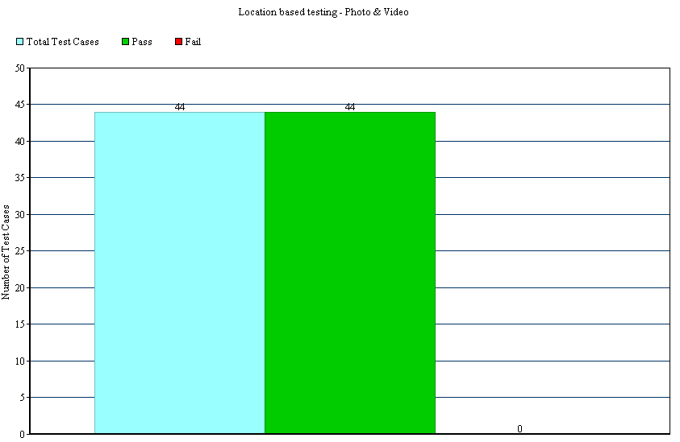

**Photo**

Total Number of Test Cases Executed = 22

Total Number of Test Cases Passed = 22

Total Number of Test Cases Failed = 00

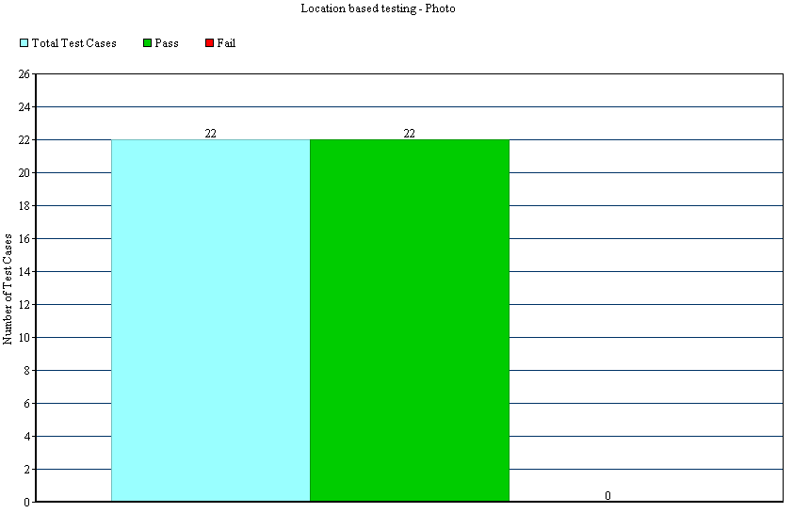

**Video**

Total Number of Test Cases Executed = 22

Total Number of Test Cases Passed = 22

Total Number of Test Cases Failed = 00

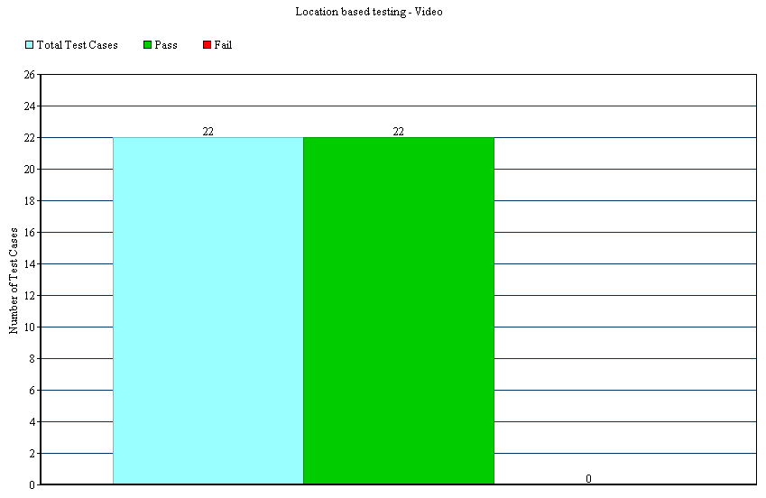

## IOS Environment –

**Decision Table**

**Application name - Instagram**

**Application Version Number – 6.1.4**

**Total (Photo & Video)**

Total Number of Test Cases Executed = 44

Total Number of Test Cases Passed = 44

Total Number of Test Cases Failed = 00



**Photo**

Total Number of Test Cases Executed = 22

Total Number of Test Cases Passed = 22

Total Number of Test Cases Failed = 00



**Video**

Total Number of Test Cases Executed = 22

Total Number of Test Cases Passed = 22

Total Number of Test Cases Failed = 00



## Signup Component–

**Black box testing -**

* **Equivalence Partition**
* **Decision Table**

## Android Environment –

**Equivalence Partitioning**

**Application name - Instagram**

**Application Version Number – 6.1.4**

Total Number of Test Cases Executed = 18

Total Number of Test Cases Passed = 18

Total Number of Test Cases Failed = 00

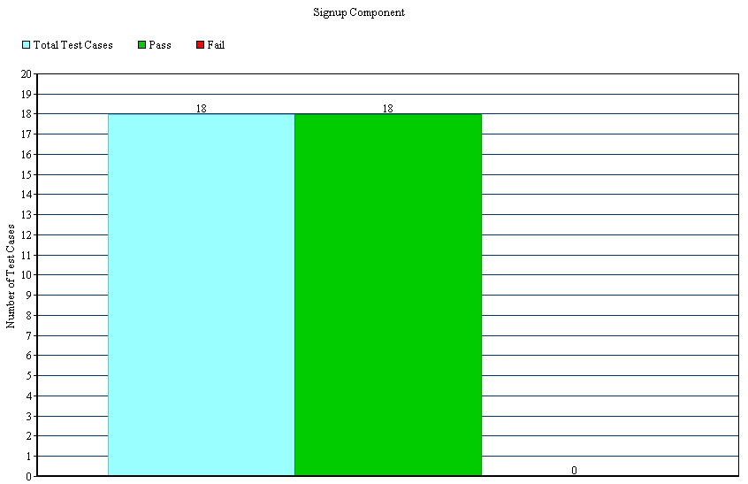

**Decision Table**

**Application name - Instagram**

**Application Version Number – 6.1.4**

Total Number of Test Cases Executed = 10

Total Number of Test Cases Passed = 08

Total Number of Test Cases Failed = 02

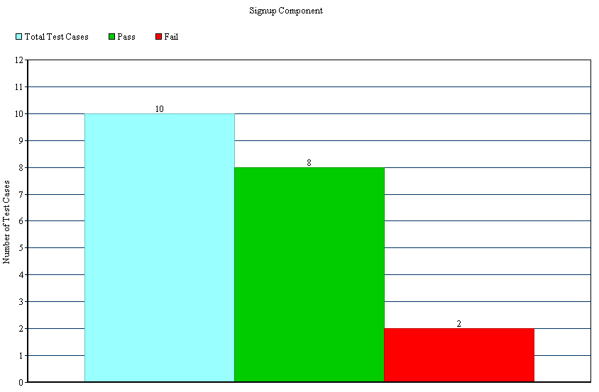

## IOS Environment –

**Equivalence Partitioning**

**Application name - Instagram**

**Application Version Number – 6.1.4**

Total Number of Test Cases Executed = 18

Total Number of Test Cases Passed = 18

Total Number of Test Cases Failed = 00



**Decision Table**

**Application name - Instagram**

**Application Version Number – 6.1.4**

Total Number of Test Cases Executed = 10

Total Number of Test Cases Passed = 08

Total Number of Test Cases Failed = 02



## Login/Forgot Password Component –

**Black box testing -**

* **Equivalence Partition**
* **Decision Table**

## Android Environment –

**Equivalence Partitioning**

**Application name - Instagram**

**Application Version Number – 6.1.4**

Total Number of Test Cases Executed = 13

Total Number of Test Cases Passed = 13

Total Number of Test Cases Failed = 00

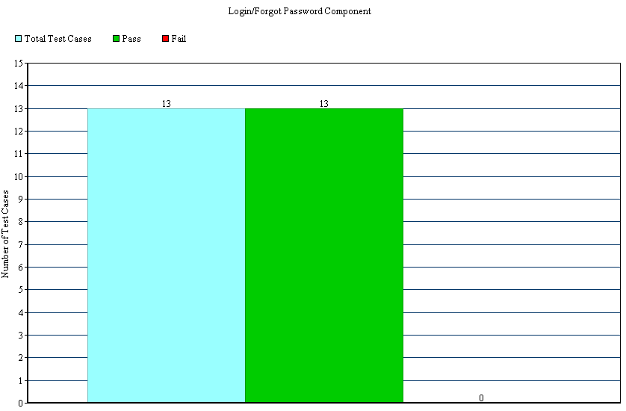

**Decision Table**

**Application name - Instagram**

**Application Version Number – 6.1.4**

Total Number of Test Cases Executed = 11

Total Number of Test Cases Passed = 11

Total Number of Test Cases Failed = 00

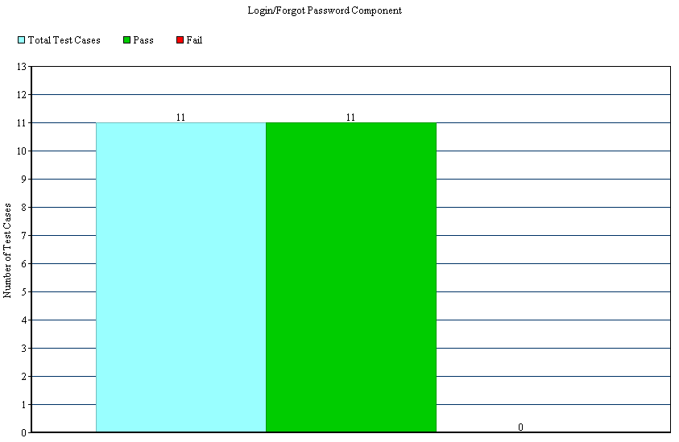

## IOS Environment –

**Equivalence Partitioning**

**Application name - Instagram**

**Application Version Number – 6.1.4**

Total Number of Test Cases Executed = 13

Total Number of Test Cases Passed = 13

Total Number of Test Cases Failed = 00



**Decision Table**

**Application name - Instagram**

**Application Version Number – 6.1.4**

Total Number of Test Cases Executed = 11

Total Number of Test Cases Passed = 11

Total Number of Test Cases Failed = 00



## Home Component –

**Black box testing -**

* **Equivalence Partition**
* **Decision Table**

## Android Environment –

**Equivalence Partitioning**

**Application name - Instagram**

**Application Version Number – 6.1.4**

Total Number of Test Cases Executed = 22

Total Number of Test Cases Passed = 22

Total Number of Test Cases Failed = 00

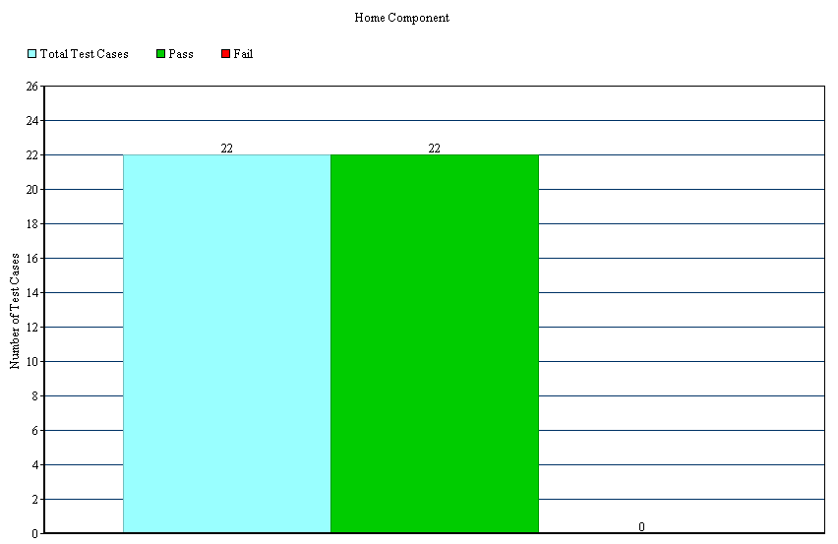

**Decision Table**

**Application name - Instagram**

**Application Version Number – 6.1.4**

Total Number of Test Cases Executed = 10

Total Number of Test Cases Passed = 10

Total Number of Test Cases Failed = 00

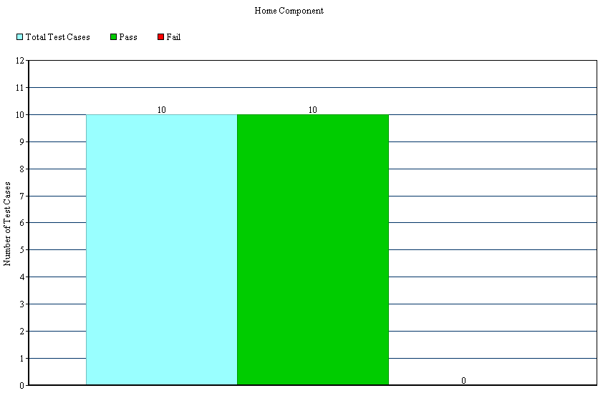

## IOS Environment –

**Equivalence Partitioning**

**Application name - Instagram**

**Application Version Number – 6.1.4**

Total Number of Test Cases Executed = 22

Total Number of Test Cases Passed = 22

Total Number of Test Cases Failed = 00



**Decision Table**

**Application name - Instagram**

**Application Version Number – 6.1.4**

Total Number of Test Cases Executed = 10

Total Number of Test Cases Passed = 10

Total Number of Test Cases Failed = 00



## Explore Component –

**Black box testing -**

* **Equivalence Partition**
* **Decision Table**

## Android Environment –

**Equivalence Partitioning**

**Application name - Instagram**

**Application Version Number – 6.1.4**

Total Number of Test Cases Executed = 09

Total Number of Test Cases Passed = 09

Total Number of Test Cases Failed = 00

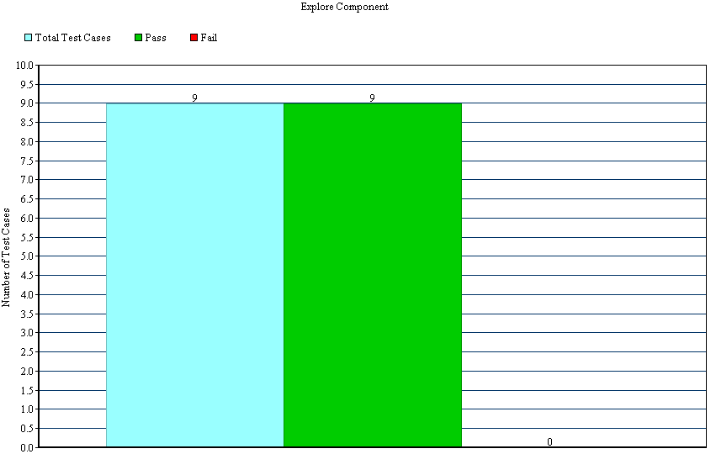

**Decision Table**

**Application name - Instagram**

**Application Version Number – 6.1.4**

Total Number of Test Cases Executed = 09

Total Number of Test Cases Passed = 09

Total Number of Test Cases Failed = 00



## IOS Environment –

**Equivalence Partitioning**

**Application name - Instagram**

**Application Version Number – 6.1.4**

Total Number of Test Cases Executed = 09

Total Number of Test Cases Passed = 09

Total Number of Test Cases Failed = 00



**Decision Table**

**Application name - Instagram**

**Application Version Number – 6.1.4**

Total Number of Test Cases Executed = 09

Total Number of Test Cases Passed = 09

Total Number of Test Cases Failed = 00



## Camera Component –

**Black box testing -**

* **Decision Table**

## Android Environment –

**Decision Table**

**Application name - Instagram**

**Application Version Number – 6.1.4**

Total Number of Test Cases Executed = 35

Total Number of Test Cases Passed = 35

Total Number of Test Cases Failed = 00

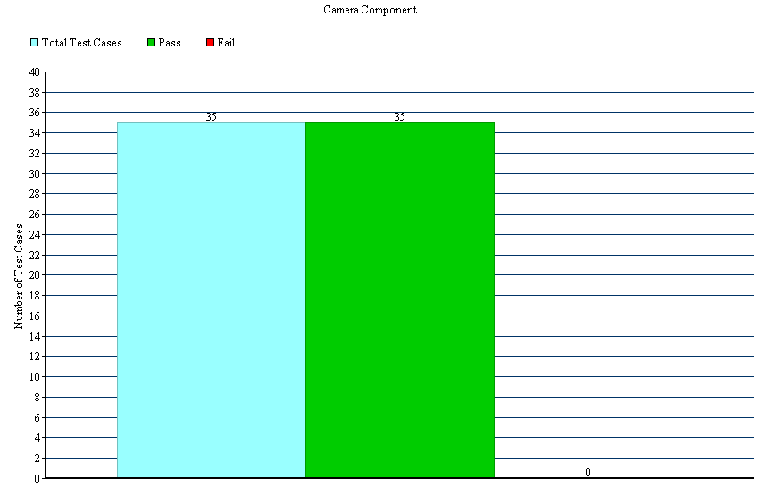

## IOS Environment –

**Decision Table**

**Application name - Instagram**

**Application Version Number – 6.1.4**

Total Number of Test Cases Executed = 35

Total Number of Test Cases Passed = 35

Total Number of Test Cases Failed = 00



## Following/News Component –

**Black box testing -**

* **Decision Table**

## Android Environment –

**Decision Table**

**Application name - Instagram**

**Application Version Number – 6.1.4**

Total Number of Test Cases Executed = 07

Total Number of Test Cases Passed = 07

Total Number of Test Cases Failed = 00

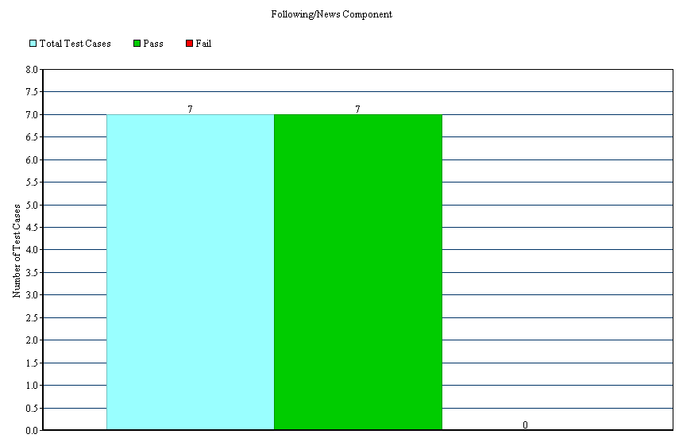

## IOS Environment –

**Decision Table**

**Application name - Instagram**

**Application Version Number – 6.1.4**

Total Number of Test Cases Executed = 07

Total Number of Test Cases Passed = 07

Total Number of Test Cases Failed = 00



## User Profile Component –

**Black box testing -**

* **Equivalence Partition**
* **Decision Table**

## Android Environment –

**Equivalence Partitioning**

**Application name - Instagram**

**Application Version Number – 6.1.4**

Total Number of Test Cases Executed = 32

Total Number of Test Cases Passed = 31

Total Number of Test Cases Failed = 01

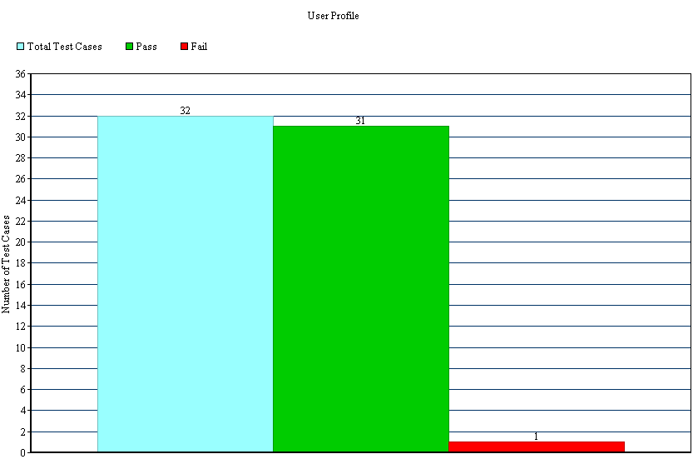

**Decision Table**

**Application name - Instagram**

**Application Version Number – 6.1.4**

Total Number of Test Cases Executed = 35

Total Number of Test Cases Passed = 35

Total Number of Test Cases Failed = 00

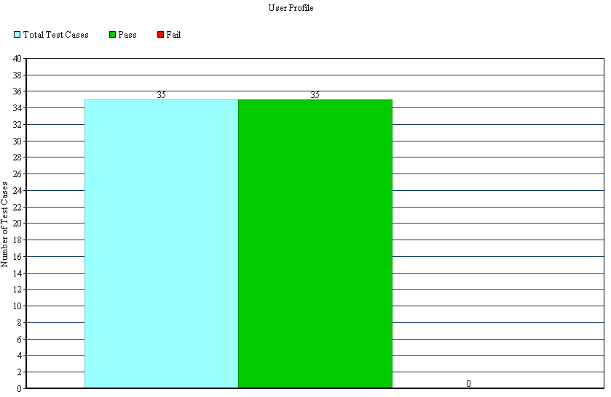

## IOS Environment –

**Equivalence Partitioning**

**Application name - Instagram**

**Application Version Number – 6.1.4**

Total Number of Test Cases Executed = 32

Total Number of Test Cases Passed = 31

Total Number of Test Cases Failed = 01



**Decision Table**

**Application name - Instagram**

**Application Version Number – 6.1.4**

Total Number of Test Cases Executed = 35

Total Number of Test Cases Passed = 35

Total Number of Test Cases Failed = 00



## Configuration Testing –

**Semantic Tree Model -**

* **Decision Table**

## Android Environment –

**Decision Table**

**Application name - Instagram**

**Application Version Number – 6.1.4**

Total Number of Test Cases Executed = 18

Total Number of Test Cases Passed = 18

Total Number of Test Cases Failed = 00

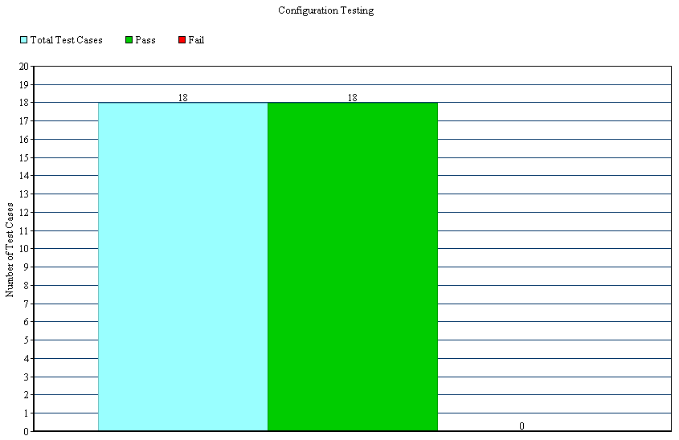

## IOS Environment –

**Decision Table**

**Application name - Instagram**

**Application Version Number – 6.1.4**

Total Number of Test Cases Executed = 18

Total Number of Test Cases Passed = 18

Total Number of Test Cases Failed = 00



## Configuration Distribution Test Result –

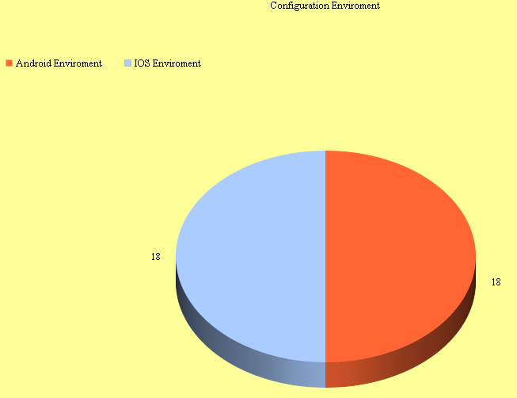

## Test Result Analysis–

Total Number of Test Cases Executed = 546

Total Number of Test Cases Passed = 540

Total Number of Test Cases Failed = 06

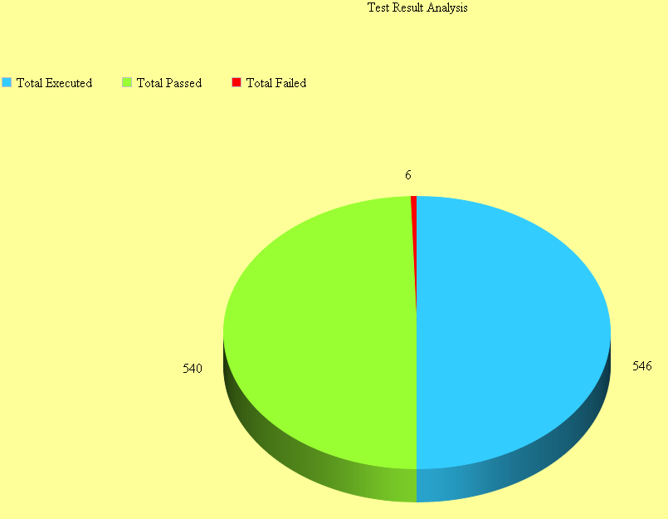

## Test Coverage Report–

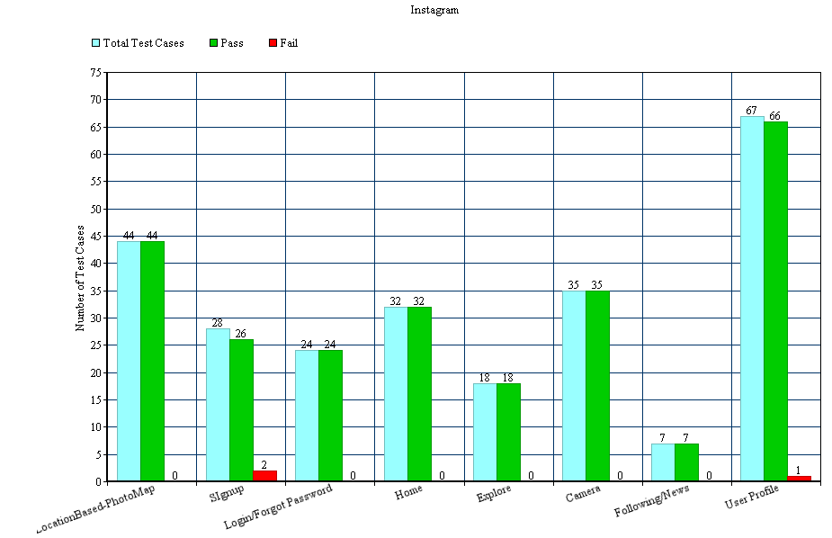

The above test cases were executed for both Android and IOS.

## **Bug Report Summary –**

The manual testing covers the execution of the test cases in order to find bugs and do the proper reporting of the same. This section describes the details of the bugs founded while testing the application Instagram.

## Bug Report with Screenshots

## Bug Report for Signup

## Bug Report for Android

|  |  |  |  |
| --- | --- | --- | --- |
| Problem ID# | PB-AND-ACC-01 | | |
| Current Software Name: | Instagram | Product Version or Release Number: | V. 6.1.4 |
| Test Type: | Black-box Testing | Test Case ID#: | IN-ACC-14 |
| Reported By: | Saumil jain | Reported Date: | 11/28/2014 |
| Subsystem (or module name) | Sign up | Feature (or Subject): | Edit Items |
| Problem Type | Security & Coding | Problem Severity: | Major |
| **Prerequisites:**  1. Install the Instagram application in the mobile device.  2. Tap on Register with Email.  **Problem Summary and Detailed Description:**  Instagram allows user to create an account with the email id which even do not exist. Currently application only checks if the format of given Id is correct but does not check if it exists or not.  **Actual results:**  Currently, the application doesn’t validate the existence of the email id given while creating the account with Instagram.  **Expected results:**  On providing the email address by user, Instagram should first check the existence of the Id provided by sending some confirmation mail to that Id. If in case, email id is not required to create an account in Instagram then it should not be asked during account creation. | | | |
| **Steps to Reproduce the issue: (Test Data must be available)**   1. Open Instagram. 2. Tap on Sign Up. 3. Tap on Register with Email. 4. Give an email address which does not exist. (This can be checked by sending an email to the Id you are using a valid existing email account. ) 5. Instagram account will be created. | | | |
| Attachments:  Screen shot when an account can be created using any email id with correct format but doesn’t exist. | | | |

|  |  |  |  |
| --- | --- | --- | --- |
| Problem ID# | PB-AND-ACC-02 | | |
| Current Software Name: | Instagram | Product Version or Release Number: | V. 6.1.4 |
| Test Type: | Black-box Testing | Test Case ID#: | IN-ACC-17 |
| Reported By: | Saumil jain | Reported Date: | 11/28/2014 |
| Subsystem (or module name) | Sign up | Feature (or Subject): | Edit Items |
| Problem Type | Security & Coding | Problem Severity: | Major |
| **Prerequisites:**  1. Install the Instagram application in the mobile device.  2. Tap on Register with Email.  **Problem Summary and Detailed Description:**  Instagram allows user to create an account with the email id which even do not exist. Currently application only checks if the format of given Id is correct but does not check if it exists or not.  **Actual results:**  Currently, the application doesn’t validate the existence of the email id given while creating the account with Instagram.  **Expected results:**  On providing the email address by user, Instagram should first check the existence of the Id provided by sending some confirmation mail to that Id. If in case, email id is not required to create an account in Instagram then it should not be asked during account creation. | | | |
| **Steps to Reproduce the issue: (Test Data must be available)**   1. Open Instagram. 2. Tap on Sign Up. 3. Tap on Register with Email. 4. Give an email address which does not exist. (This can be checked by sending an email to the Id you are using a valid existing email account. ) 5. Instagram account will be created. | | | |
| Attachments:  Screen shot when an account can be created using any email id with correct format but doesn’t exist. | | | |

## Bug Report for IOS

|  |  |  |  |
| --- | --- | --- | --- |
| Problem ID# | PB-IOS-ACC-01 | | |
| Current Software Name: | Instagram | Product Version or Release Number: | V. 6.1.4 |
| Test Type: | Black-box Testing | Test Case ID#: | IN-ACC-14 |
| Reported By: | Saumil jain | Reported Date: | 11/28/2014 |
| Subsystem (or module name) | Sign up | Feature (or Subject): | Edit Items |
| Problem Type | Security & Coding | Problem Severity: | Major |
| **Prerequisites:**  1. Install the Instagram application in the mobile device.  2. Tap on Register with Email.  **Problem Summary and Detailed Description:**  Instagram allows user to create an account with the email id which even do not exist. Currently application only checks if the format of given Id is correct but does not check if it exists or not.  **Actual results:**  Currently, the application doesn’t validate the existence of the email id given while creating the account with Instagram.  **Expected results:**  On providing the email address by user, Instagram should first check the existence of the Id provided by sending some confirmation mail to that Id. If in case, email id is not required to create an account in Instagram then it should not be asked during account creation. | | | |
| **Steps to Reproduce the issue: (Test Data must be available)**   1. Open Instagram. 2. Tap on Sign Up. 3. Tap on Register with Email. 4. Give an email address which does not exist. (This can be checked by sending an email to the Id you are using a valid existing email account. ) 5. Instagram account will be created. | | | |
| Attachments:  Screen shot when an account can be created using any email id with correct format but doesn’t exist. | | | |

|  |  |  |  |
| --- | --- | --- | --- |
| Problem ID# | PB-IOS-ACC-02 | | |
| Current Software Name: | Instagram | Product Version or Release Number: | V. 6.1.4 |
| Test Type: | Black-box Testing | Test Case ID#: | IN-ACC-17 |
| Reported By: | Saumil jain | Reported Date: | 11/28/2014 |
| Subsystem (or module name) | Sign up | Feature (or Subject): | Edit Items |
| Problem Type | Security & Coding | Problem Severity: | Major |
| **Prerequisites:**  1. Install the Instagram application in the mobile device.  2. Tap on Register with Email.  **Problem Summary and Detailed Description:**  Instagram allows user to create an account with the email id which even do not exist. Currently application only checks if the format of given Id is correct but does not check if it exists or not.  **Actual results:**  Currently, the application doesn’t validate the existence of the email id given while creating the account with Instagram.  **Expected results:**  On providing the email address by user, Instagram should first check the existence of the Id provided by sending some confirmation mail to that Id. If in case, email id is not required to create an account in Instagram then it should not be asked during account creation. | | | |
| **Steps to Reproduce the issue: (Test Data must be available)**   1. Open Instagram. 2. Tap on Sign Up. 3. Tap on Register with Email. 4. Give an email address which does not exist. (This can be checked by sending an email to the Id you are using a valid existing email account. ) 5. Instagram account will be created. | | | |
| Attachments:  Screen shot when an account can be created using any email id with correct format but doesn’t exist. | | | |

## Bug Report for User Profile

## Bug Report for Android

|  |  |  |  |
| --- | --- | --- | --- |
| Problem ID# | PB-AND-UP-01 | | |
| Current Software Name: | Instagram | Product Version or Release Number: | V. 6.1.4 |
| Test Type: | Black-box Testing | Test Case ID#: | INM-UP -21 |
| Reported By: | Shilpa | Reported Date: | 11/28/2014 |
| Subsystem (or module name) | User Profile Component | Feature (or Subject): | Edit Items |
| Problem Type | Security & Coding | Problem Severity: | Major |
| **Prerequisites:**  1. Install the Instagram application in the mobile device.  2. Logged in the application with valid user account.  **Problem Summary and Detailed Description:**  Instagram allows user to update its email id to an Id which even do not exist. Currently application only checks if the format of given Id is correct but does not check if it exists or not. The existing user account is linked to an Id which even doesn’t exist. All new communication as forgot password notification and other will be forwarded to an Id which even does not exist.  **Actual results:**  Currently, the application doesn’t validate the existence of the email id given while updating the user profile with Instagram.  **Expected results:**  On providing the email Id by user, Instagram should first check the existence of the Id provided by sending some confirmation mail to that Id. | | | |
| **Steps to Reproduce the issue: (Test Data must be available)**   1. Go to User profile. 2. Tap “Edit Your Profile”. 3. Tap Email to edit it. 4. Give an email address which does not exist. (This can be checked by sending an email to the Id you are using a valid existing email account.) | | | |
| Attachments:  Screen shot when user updated its email id with correct format but doesn’t exist. | | | |

## Bug Report for IOS

|  |  |  |  |
| --- | --- | --- | --- |
| Problem ID# | PB-IOS-UP-01 | | |
| Current Software Name: | Instagram | Product Version or Release Number: | V. 6.1.4 |
| Test Type: | Black-box Testing | Test Case ID#: | INM-UP -21 |
| Reported By: | Shilpa | Reported Date: | 11/28/2014 |
| Subsystem (or module name) | User Profile Component | Feature (or Subject): | Edit Items |
| Problem Type | Security & Coding | Problem Severity: | Major |
| **Prerequisites:**  1. Install the Instagram application in the mobile device.  2. Logged in the application with valid user account.  **Problem Summary and Detailed Description:**  Instagram allows user to update its email id to an Id which even do not exist. Currently application only checks if the format of given Id is correct but does not check if it exists or not. The existing user account is linked to an Id which even doesn’t exist. All new communication as forgot password notification and other will be forwarded to an Id which even does not exist.  **Actual results:**  Currently, the application doesn’t validate the existence of the email id given while updating the user profile with Instagram.  **Expected results:**  On providing the email Id by user, Instagram should first check the existence of the Id provided by sending some confirmation mail to that Id. | | | |
| **Steps to Reproduce the issue: (Test Data must be available)**   1. Go to User profile. 2. Tap “Edit Your Profile”. 3. Tap Email to edit it. 4. Give an email address which does not exist. (This can be checked by sending an email to the Id you are using a valid existing email account.) | | | |
| Attachments:  Screen shot when user updated its email id with correct format but doesn’t exist. | | | |

## Bug Reporting in Bugzilla

## Android

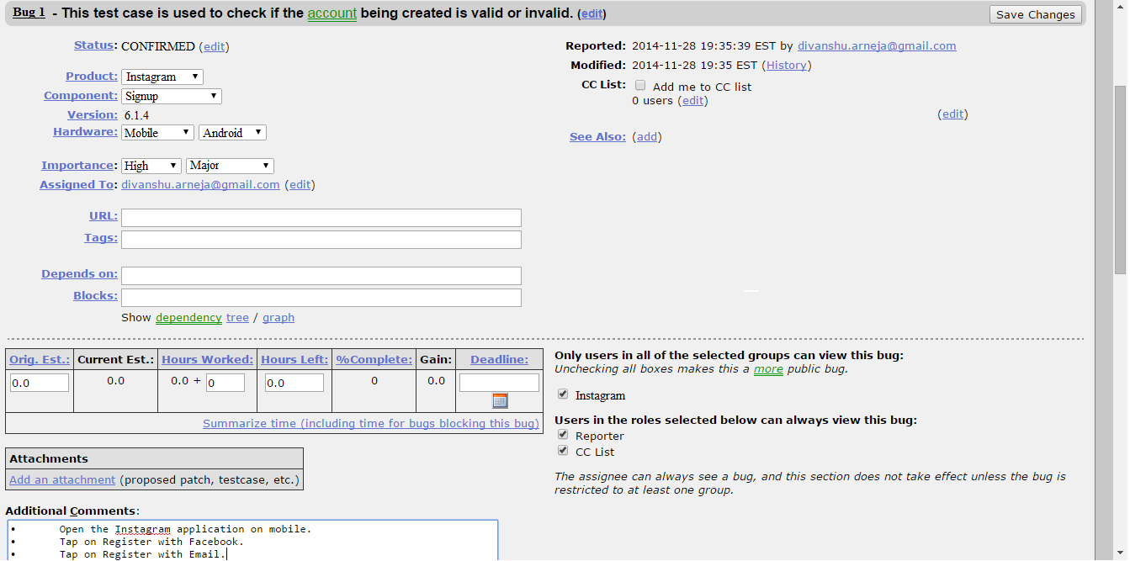

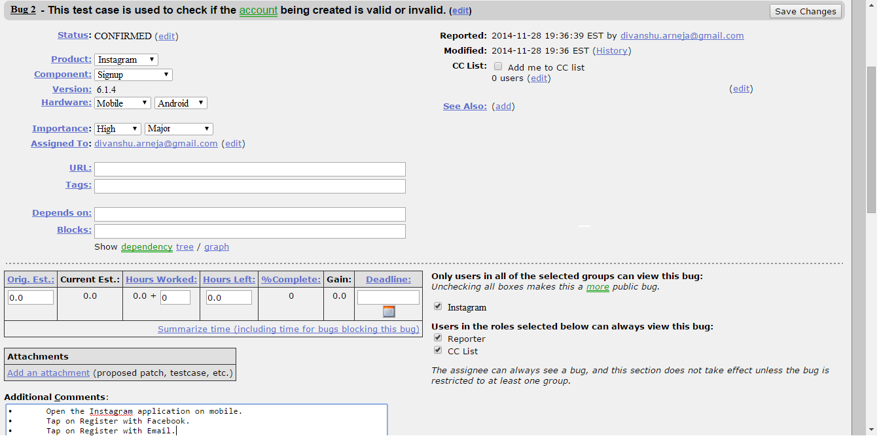

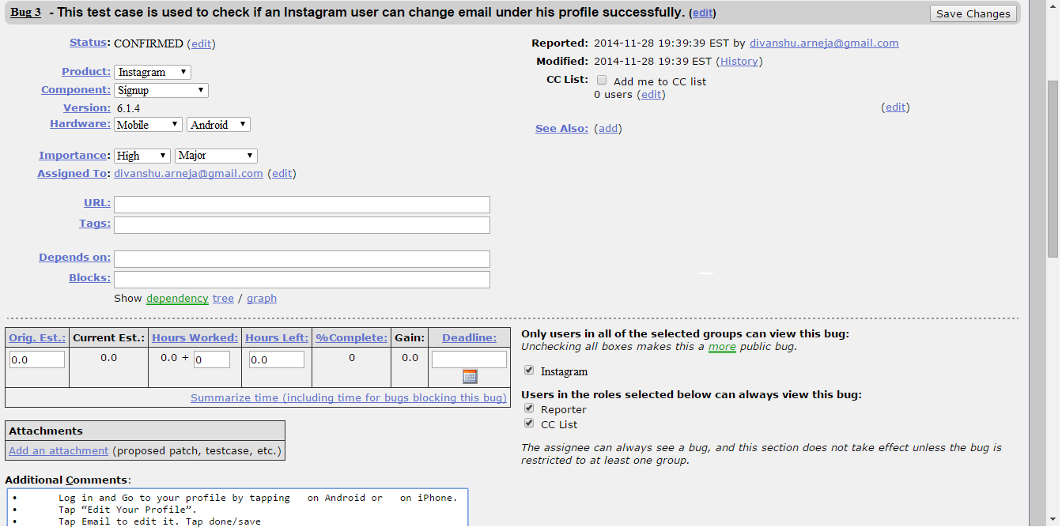

## IOS

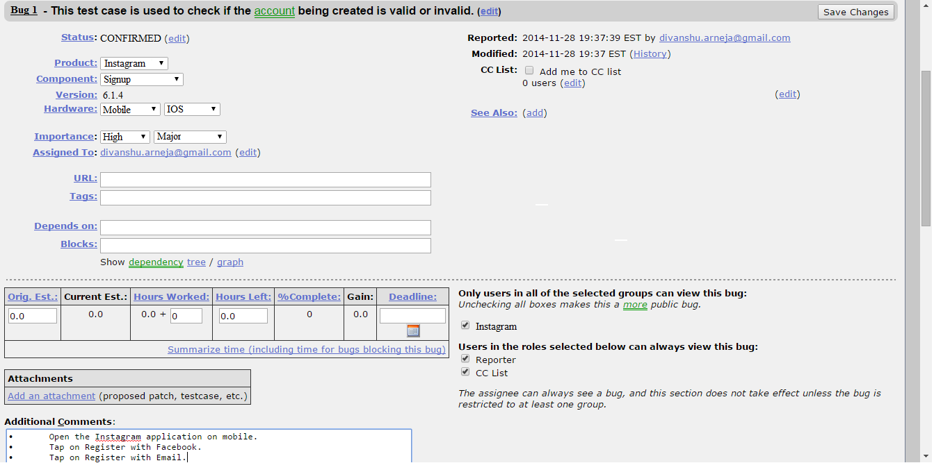

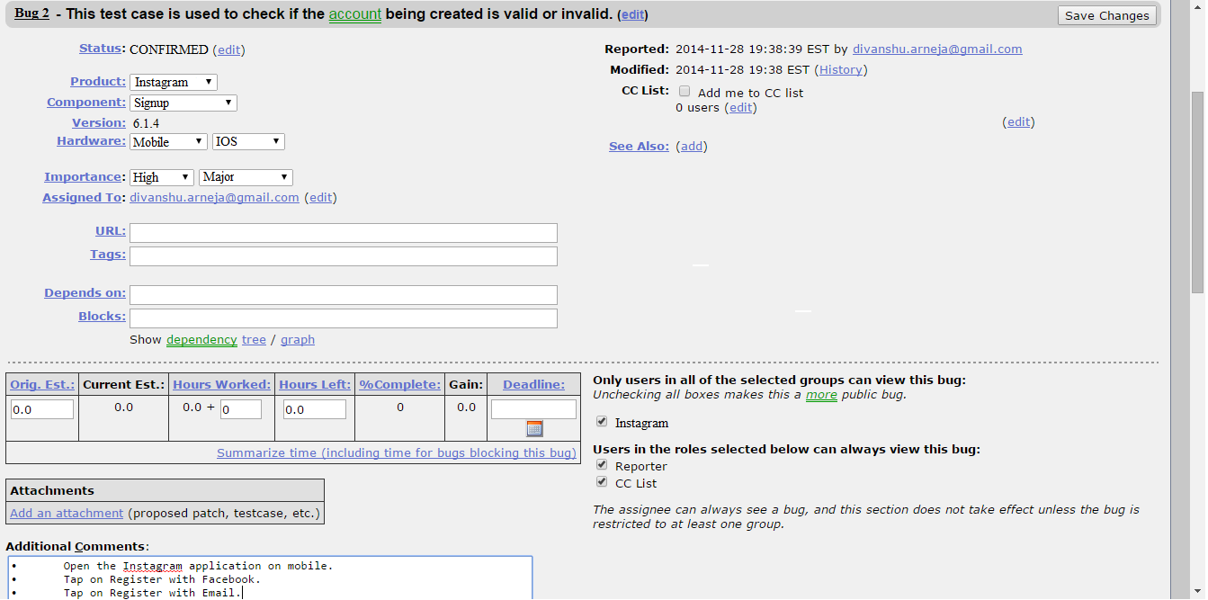

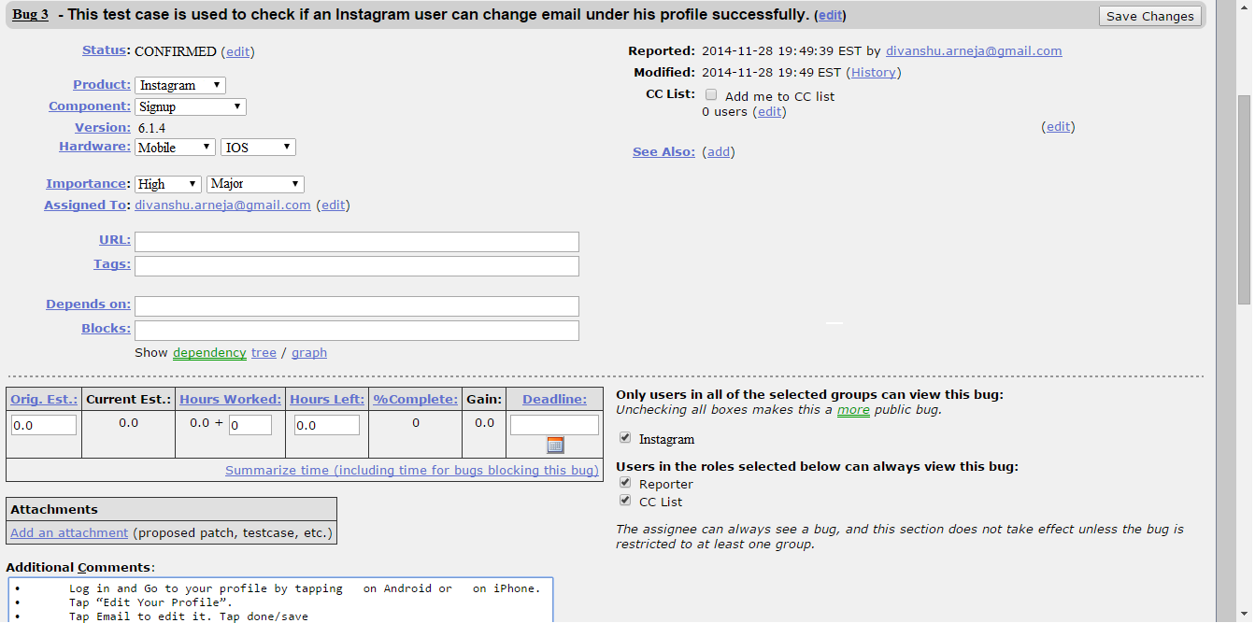

## Bug Reporting in Elementool – Issue tracker

**Bugs reporting for Sign up**

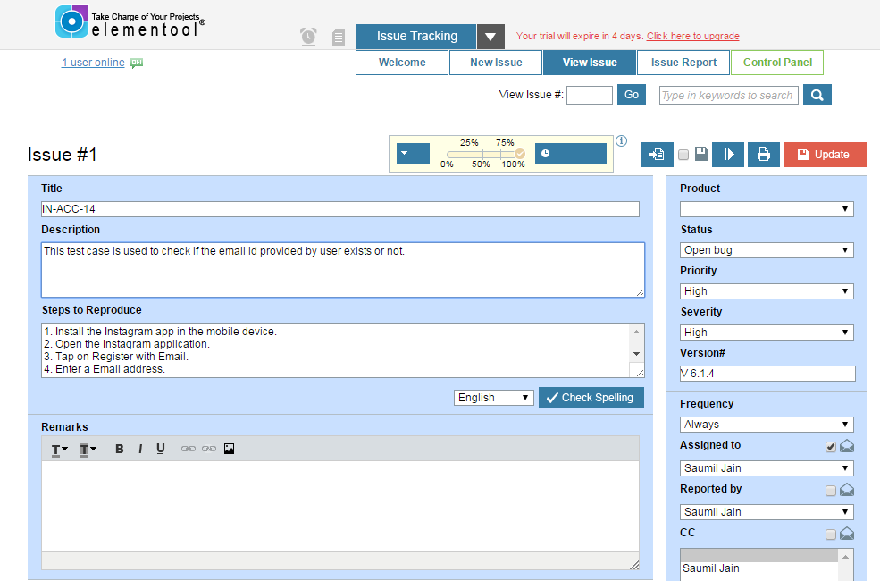

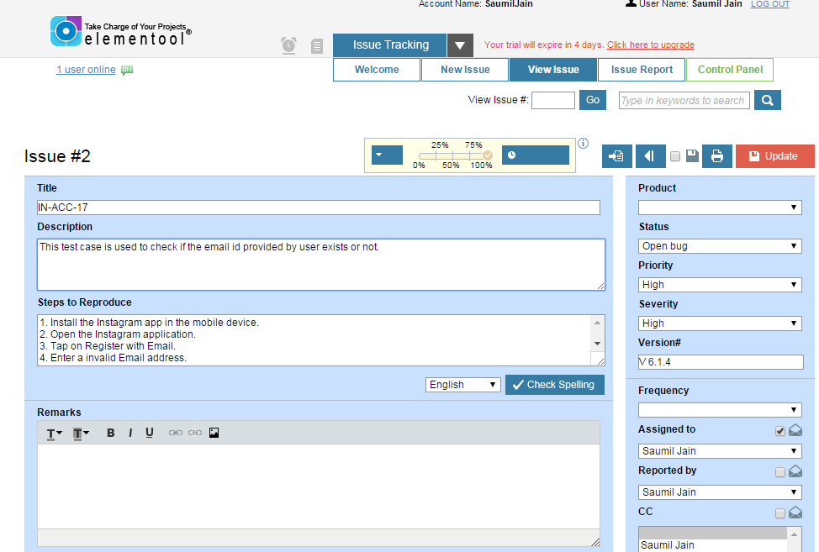

**Bugs reporting for User Profile**

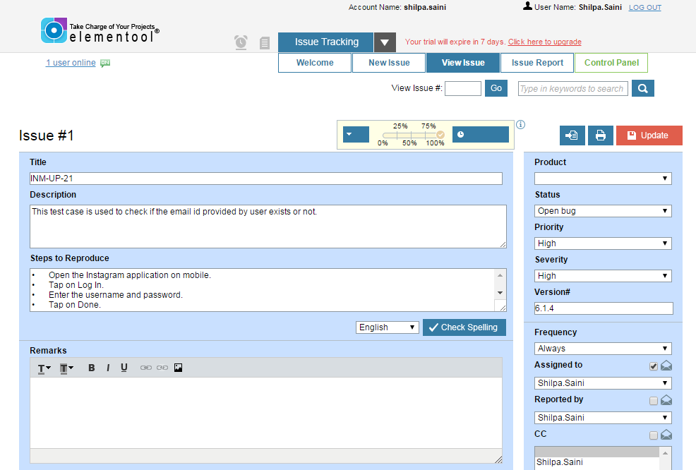

## Features vs Bug Report

1. Location based Testing of Photo Map – 0 bugs
2. Signup Component – 2 bugs
3. Login/Forgot Password Component– 0 bugs
4. Home Component– 0 bugs
5. Explore Component– 0 bugs
6. Camera Component– 0 bugs
7. Following/News Component– 0 bugs
8. User Profile Component– 1 bugs

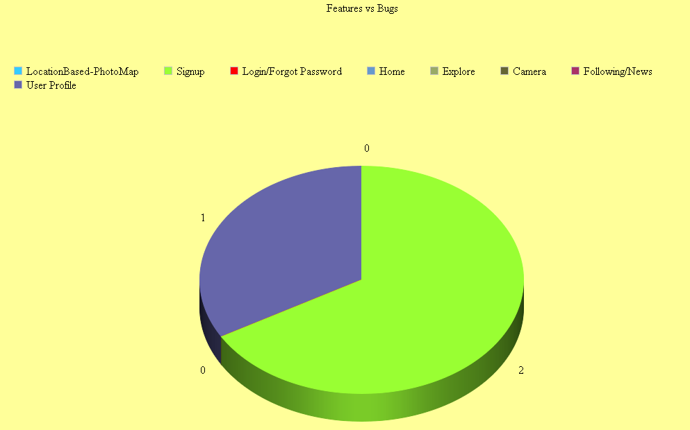

## Bugs Report with respect to environment and Feature

Instagram has 3 bugs in both Android and IOS environment. The below diagram shows the number of bugs found for each feature for both the environment.

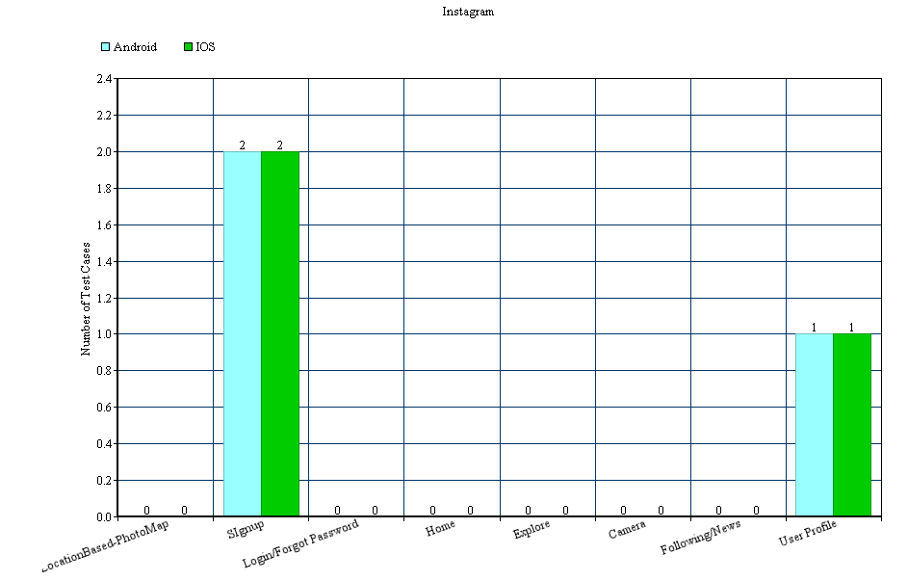

## **Software test cost and complexity -**

## Software Test Cost –

This section discusses the cost of testing the application. The testing cost can be categorized in the following below areas -

* Infrastructure cost
* Tool cost
* Human Resource cost

## Infrastructure Cost

‘Instagram’ application can be tested via a physical device – Mobile or on an emulator. We have tested the application using mobile device - Android and IOS smartphones.

The following table illustrates the cost of mobile devices.

|  |  |
| --- | --- |
| **Device** | **Cost** |
| IOS Device | $249-$649 |
| Android Device | $199-$630 |

## Tool Cost

For reporting of all the tests and their related bugs, we used the below two tools –

Elementool and Bugzilla

Elementool is usually free for a 7 days trail after that a subscription is required.

Bugzilla is an open source bug tracking system.

## Human Resource Cost

A team of 5 tested the Instagram application –

|  |  |  |  |
| --- | --- | --- | --- |
| **Resource Name** | **Hours (per day)** | **Total no.of days worked** | **Total cost(per resource)** |
| Divanshu Arneja | 5 | 4 (November 24,25,26,27) | $150.00 |
| Shilpa | 5 | 4 (November 24,25,26,27) | $150.00 |
| Saumil Jain | 5 | 4 (November 24,25,26,27) | $150.00 |
| Piyush Seth | 5 | 4 (November 24,25,26,27) | $150.00 |
| Surbhi Rautji | 5 | 4 (November 24,25,26,27) | $150.00 |

## Software Testing Complexity

Software testing complexity is a measured on the complexity scale i.e. how difficult it is to test an application.

Complexity of Instagram application is measured by the number of components that were tested on both Andriod and IOS devices.

The components are -

1. Signup Component
2. Login/Forgot Password Component
3. Home Component
4. Explore Component
5. Camera Component
6. Following/News Component
7. User Profile Component
8. Location based Testing of Photo Map

So, to test the application, we used –

* Black box testing like Equivalence partitioning and Decision Table testing.

To test the configuration environment, we used –

* Semantic tree testing model, with which we ensured various type of connectivity on both the operating system platforms.

Overall we covered the whole testing of the application and we tested five hundred fourty six test cases out of which five hundred fourty were passed and six were failed.

## **Summary -**

In the conclusion, we tested the application for all the coverage and all possible test cases. We also provided the best test result analysis with respect to all the GUI features; location based testing, configurations, environment, platforms, and connectivity in pictorial format.

The diagram below is the summary of different testing methods used for each feature.

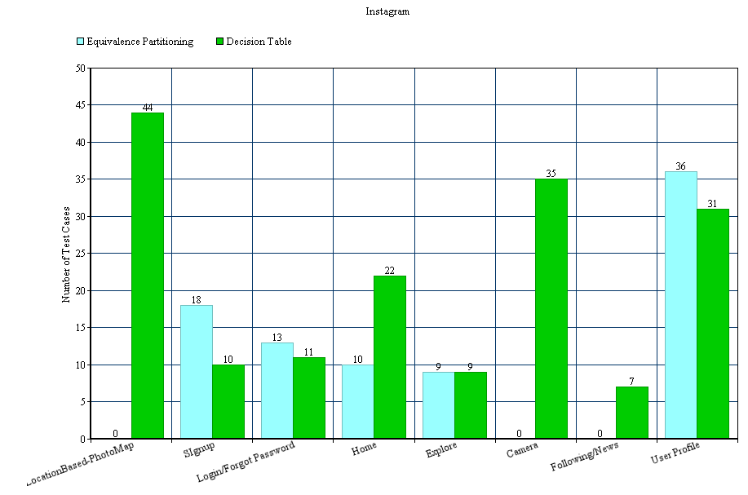

## **References**

1. *Gao, J., Tsao, H. S., & Wu, Y. (2003). Testing and quality assurance for component-based software. Artech House.*
2. *Gao, J., Espinoza, R., & He, J. (2005, July). Testing coverage analysis for software component validation. In Computer Software and Applications Conference, 2005. COMPSAC 2005. 29th Annual International (Vol. 1, pp. 463-470). IEEE.*
3. *Gao, J., Espinoza, R., & He, J. (2005, July). Testing coverage analysis for software component validation. In Computer Software and Applications Conference, 2005. COMPSAC 2005. 29th Annual International (Vol. 1, pp. 463-470). IEEE.*
4. *Gao, J.,Bai Xiaoying, Tsai Wei-Tek , and Uehara ,Tadahiro. Mobile Application Testing :A tutorial,* Retrieved on 3rd March 2014 from [*https://sjsu.instructure.com/courses/1070405/files#SP14%3A%20CMPE-287%20Sec%2001%20-%20SW%20Qlty%20Assur%2Fmobile-testing-and-resources%2Fr2gao-v3-IEEE-Computer-Paper.pdf*](https://sjsu.instructure.com/courses/1070405/files#SP14%3A%20CMPE-287%20Sec%2001%20-%20SW%20Qlty%20Assur%2Fmobile-testing-and-resources%2Fr2gao-v3-IEEE-Computer-Paper.pdf)
5. *Gao, Jerry. "Testing Component-Based Software." Proc. of STARWest, San Jose, USA (1999).*
6. *CmpE 287 slides and class notes*